Flame Thrower Demo

Cornstarch Formula C₂₇H₄₈O₂₀ ( )

Cornstarch Structure

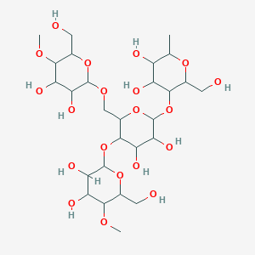

Photosynthesis BCE

____________________________________________________________________________

Formation of starch from glucose

____________________________________________________________________________

https://www.youtube.com/watch?v=0gBB4jquYz0

Crash Course You are what you eat
https://www.youtube.com/watch?v=H8WJ2KENlK0

Crash Course Chemistry Polymers
https://www.youtube.com/watch?v=rHxxLYzJ8Sw

Photosynthesis BCE

____________________________________________________________________________

Formation of starch from glucose

____________________________________________________________________________

Cornstarch on spatula

Cornstarch in funnel

Combustion Reaction of Starch BCE

____________________________________________________________________________

Rate of Reaction Difference btw the Spatula and the Funnel—WHY?
Use Collision Theory!

