Factors that affect the Rate of Reaction between an Acid and a Metal
Purpose:
- to determine how the nature of a reactant affects the rate of a reaction
- to determine how the concentration of a reactant affects the rate of a reaction
Ms. Purcell or Mme. Veilleux will explain to you the set up according to the following diagram:
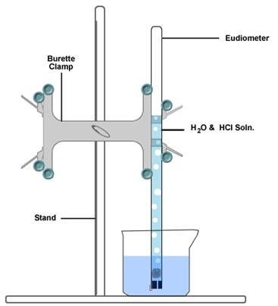
Trial 1 First Column Lab Partners
- piece of magnesium metal and approx. 10 mL of 3 mol/L HCl(aq)
Trial 2 Second Column Lab Partners
- piece of magnesium metal and approx. 10 mL of 6 mol/L HCl(aq)
Trial 3 Third Column Lab Partners
- piece of magnesium metal and approx. 10 mL of 6 mol/L CH₃COOH(aq)
Observations:
- in your log books create 3 data tables
- first column of each table is time
- second column of each table is volume of hydrogen gas
- you will collect only one set of data
- you will obtain the other 2 sets of data from your "row mates"
BCE:
1___________________________________________________________________________

2___________________________________________________________________________

Analyses of Data:
1) Computer generate ONE graph using the 3 sets of data. Use a legend.

2) Determine the average rate of formation of hydrogen gas over time for each set of data.
Trial 1 Average Rate for 3 M HCl:

Trial 2 Average Rate for 6 M HCl:

Trial 3 Average Rate for 6 M CH₃COOH:

How does the type of acid affect the rate of reaction and why using collision theory?
____________________________________________________________________________
____________________________________________________________________________

How does the concentration of acid affect the rate of reaction and why using collision theory?
____________________________________________________________________________
____________________________________________________________________________

What were the 2 independent variables?
- __________________________________

- __________________________________
What was the dependent variable? _________________________________

List everything that was held constant (use bullets).

