Name: ____________________________________
Partners: ____________________________________
____________________________________

Factors that affect the Rate of Reaction between an Acid and a Metal
Purpose:
- to determine how the nature of a reactant affects the rate of a reaction
- to determine how the concentration of a reactant affects the rate of a reaction
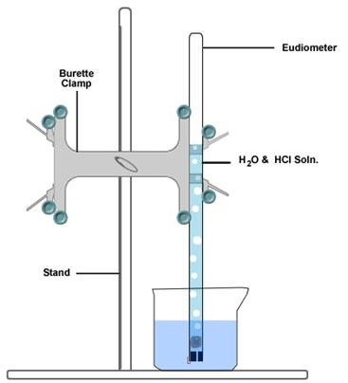
Experiment 1 First Column Lab Partners
- piece of magnesium metal and approx. 10 mL of 3.0 mol/L HCl(aq)
Experiment 2 Second Column Lab Partners
- piece of magnesium metal and approx. 10 mL of 6.0 mol/L HCl(aq)
Experiment 3 Third Column Lab Partners
- piece of magnesium metal and approx. 10 mL of 6.0 mol/L CH₃COOH(aq)
Observations:
- create a data table for volume vs. time
- first column (time)
- second column ( volume of hydrogen gas)
- you will collect only one set of data
- you will obtain the other 2 sets of data from your "row mates" by taking photos
BCEs:
1___________________________________________________________________________

2___________________________________________________________________________
Analyses of Data:
1) By computer generate ONE GRAPH using the 3 sets of data. Use a legend.
2) Determine the average rate of formation of hydrogen gas over time for each set of data.
Average Rate of Formation of Hydrogen Gas = Total Volume of Hydrogen
Total Time

Experiment 1 Calculated Average Rate for 3 M HCl:

Experiment 2 Calculated Average Rate for 6 M HCl:

Experiment 3 Calculated Average Rate for 6 M CH₃COOH:

How does the type of acid affect the rate of reaction and why using COLLISION THEORY?

____________________________________________________________________________

____________________________________________________________________________

____________________________________________________________________________

____________________________________________________________________________

How does the concentration of acid affect the rate of reaction and why using COLLISION THEORY?

____________________________________________________________________________

____________________________________________________________________________

____________________________________________________________________________

Two different variables were tested in the lab.
What were the 2 independent variables?

- _____________________________________________________

- _____________________________________________________

What was the dependent variable in each case? ___________________________________________

List everything that was held constant (use bullets)--at least 5.

_____________________________________________________________________________________________

_____________________________________________________________________________________________

_____________________________________________________________________________________________

Why could we use a copper cage to hold the magnesium metal?

____________________________________________________________________________________________

____________________________________________________________________________________________

