The lithosphere and the hydrosphere
ChaptEr 6
EST
Questions 1–36 and A–D

Checkups and follow-ups
12. In the Canadian Arctic, houses are sinking into the ground, and runways are cracking. Explain your answer.
13. Is there any vegetation in the Far North of Québec? Explain your answer.
14. Vicky, who lives in the village of Kuujjuaq in northern Québec, wants to build a house on
piles.
a) Given that the active layer in her region is 1.5 m thick, how long should the piles be? Explain your answer.
b) Can Vicky be sure of the long-term stability of her house?

15. Name three fuels that come directly from the lithosphere.

16. Name the form of energy described in each statement.
a) It is produced by atomic fission.
b) It is the result of the decomposition of prehistoric plants and animals.
c) It is derived from the internal heat of the Earth.
d) It emits more greenhouse gases than any other form of energy.
e) It leaves behind radioactive waste.
f) It is in danger of running out within the next few decades.
17. Name three farming practices that lead to soil depletion.
18. Name one advantage and one disadvantage
of using heavy machinery on farmland.
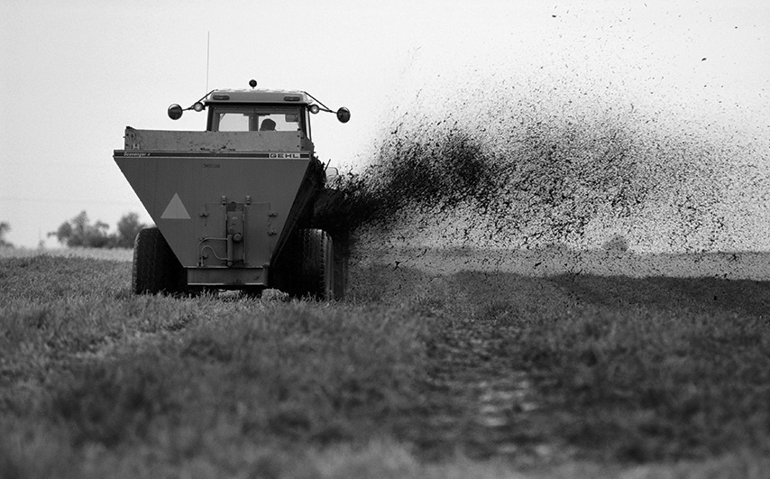
19. Nitrogen oxides (NO_{x}) and sulphur dioxide (SO₂) are emitted by car engines and industrial
processes.
a) What happens when they come into contact with rainwater?
b) How does this rain affect the soil?

