THE hydrosphEre (pp. 200–213)
20. What am I? I represent 2.5 percent of the hydrosphere, and 79 percent of my total volume is
contained in glaciers.
21. Name five forms of water in the hydrosphere.
22. Environmental experts divide inland waters among watersheds. How do they define the
boundaries of watersheds?
23. Name four factors that affect the flow of water within a watershed.
24. The differences in seasonal temperatures are not as great in the ocean as on land.
a) Explain your answer.
b) Name three factors that affect the temperature of ocean waters.
25. Is seawater more saline at the poles or in the tropics? Explain your answer.

26. What am I?
a) I am a wind-driven ocean current.
b) I am an ocean current caused by differences in water density.
c) I form a huge “conveyor belt” that transports ocean waters around the world.
27. Name three factors that affect ocean circulation.
28. Which water is denser?
a) water with three-percent salinity or water with four-percent salinity?
b) water at 12°C or water at 18°C?
29. What is the cryosphere?
30. The two photos opposite were taken during a trip to the Arctic.
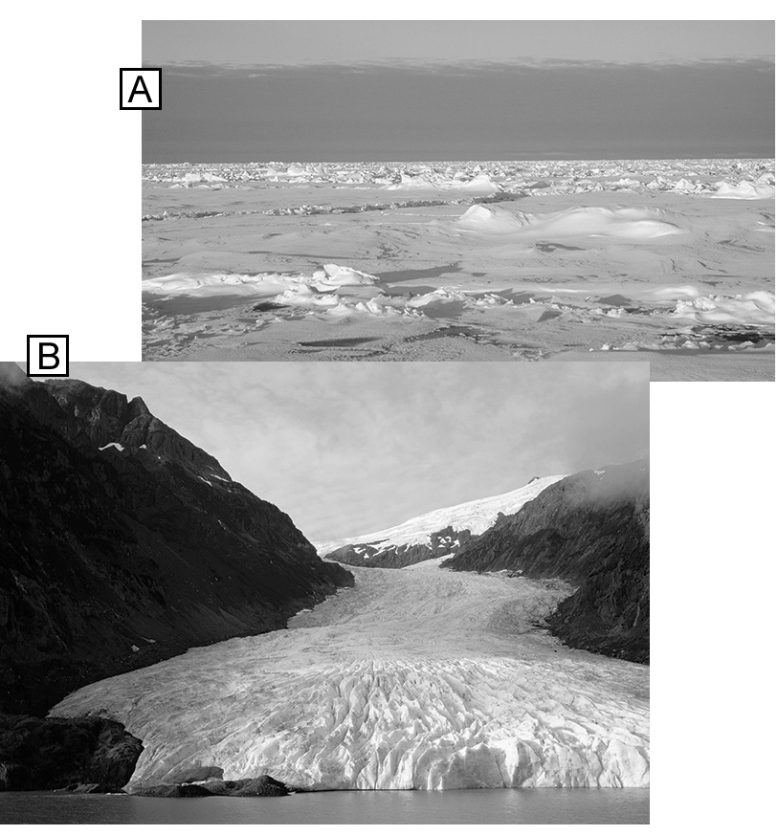
a) Which photo features pack ice?
b) What distinguishes the glacier from the pack ice?
31. What impact can melting pack ice have on the
environment?
32. Name two consequences of melting ice in the Greenland and Antarctic ice sheets.
33. Name one advantage of hydroelectric power.
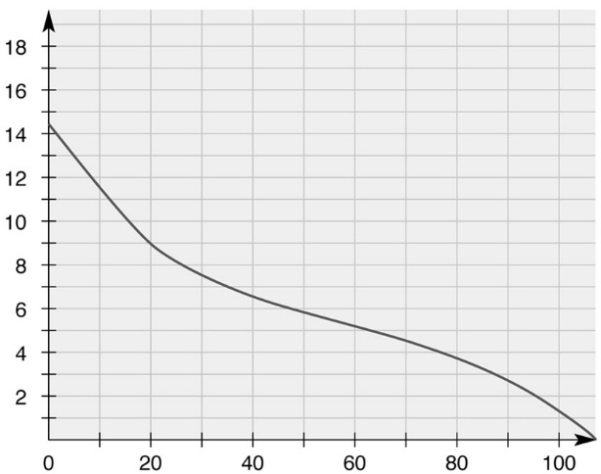
34. Look at the graph opposite. What does it demonstrate?
Oxygen solubility (mg/L)
35. A gold mine on the banks of a river discharges
water that was used to cool the ingots. The
wastewater has a temperature of 22°C, while
the river water is at 14°C. How will the wastewater discharge affect the river?
Water temperature (°C)
- Place the stages of eutrophication in the correct order.
A. drop in the oxygen concentration of the water
B. growth of algae
C. increase in the phosphorus concentration of the water
D. decomposition of algae

REVIEW QUESTIONS
B. To mine the deposit described in question A, the company must set up a camp.
a) The camp is not connected to a power grid, so the geologists install gas-powered generators. Which polluting gases will be emitted by the camp?
b) One of the geologists, who must spend the summer at this remote camp, decides to grow a vegetable garden. Given that the deposit is in the Canadian Shield—known for its low buffering capacity—which environmental problem could affect the geologist’s gardening plans?
C. Cruise ships regularly offer tours along the shores of Greenland. Tourists can observe the spectacular blocks of ice that break off from the coast and fall into the sea.
a) What are these blocks of ice called?
b) A few fragments of ice melt in the seawater. This water does not stay near the coast; it moves about. What factors will affect its movement?
c) Will the meltwater eventually arrive at the equator? Explain your answer.
d) In certain places, the Greenland glaciers are melting at twice their previous rate. Which climatic phenomenon explains this acceleration?
Follow-up
1. The Inuit diet consists mainly of food that the people have hunted or fished and food that has been brought in from southern regions. How does climate change interfere with their diet?
2. Although Inuit are responsible for a tiny fraction of global greenhouse gas emissions, they are more profoundly affected by climate change than any other population. How can people living farther south demonstrate solidarity with their northern neighbours?

