It's time to learn a little more!
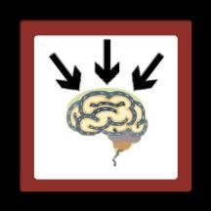
At this point it's time to demystify electronics. Now we'll present various activities which will allow you to better understand how the targeted components work. Afterwards, we can approach the fabrication of a printed circuit on which these components will interact.

Learning activities to be broached
- Electronic components
- Description of electronic components
- Recognition exercise: components and their symbols

- Resistor
- Characteristics of the fixed resistor
- Variable resistor

- Capacitor
- Ceramic capacitor
- Electrolytic capacitor

- Diode
- Light emitting diode (LED)
- Ordinary diode

- Solenoid
- Electromagnet
- Relay
- Single bobbin (inductance) ⇒ Electromagnetic induction

- Transistor

- Theory regarding printed circuits
- Making the plate
- Controlling the state of its operation
- Tin soldering

Electronic components
Here now is the description of the components targeted in the fourth year high school AST program. Identify each of the components among those distributed.

Name and description | Photo | Symbol
RESISTOR
Fixed resistor  A resistor has a fixed resistance (R) which is measured in ohms (Ω). A code made up of coloured strips indicates its value. | 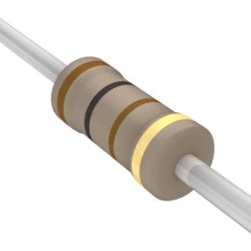  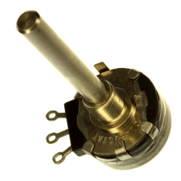  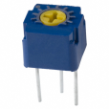  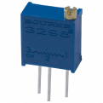
Variable resistor
The resistance of a variable resistor can be adjusted from 0 Ω to a predetermined value indicated on its back.
CAPACITOR
Ceramic capacitor  A capacitor has a capacity (C) that is measured in farad (F). This value is usually written on its side. | 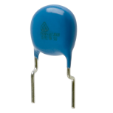  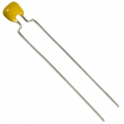  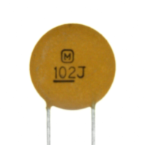  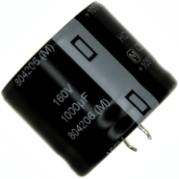  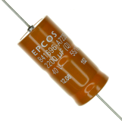  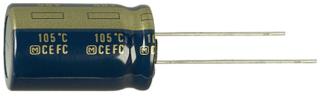  Cathode
Electrolytic capacitor
This type of capacitor has a greater capacity. It is polarised and its cathode (-) is usually indicated by minus signs. Its capacity and maximum voltage (not to be surpassed) are indicated.

Name and description | Photo | Symbol
DIODE
Ordinary diode  A diode is a polarised component. The cathode (-) is indicated by a line at one of its ends. | 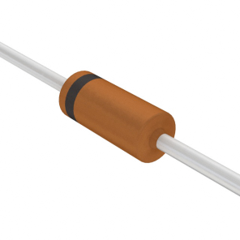  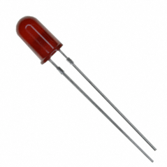  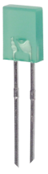  +  _  Anode  Cathode  +  _  Anode  Cathode  +  _  short electrode  meplat  Cathode
Light emitting diode
An LED can emit several colours and is polarised. The cathode (-) is usually indicated by the shorter electrode and by its meplat (flat side).
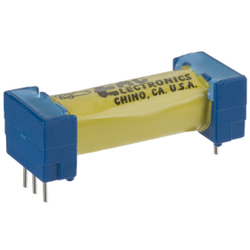
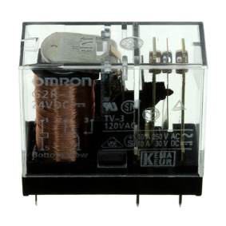
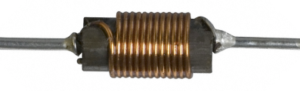
SOLENOID
Relay
The relay is always made up of an electromagnet and contact strips. The operating voltage of the solenoid as well as the maximum voltage of its strips are indicated on its housing.
Solenoid
A solenoid has an inductance (L) measured in Henry (H).

Name and description | Photo |  | Symbol
BIPOLAR TRANSISTOR
There are many types of transistors. We will concentrate only on the bipolar transistor. This transistor is made up of 3 electrodes: the emitter (E), the base (B), and the collector (C). The position of each one varies depending upon which model is used. The number of the transistor is written on its side. There are 2 major types of bipolar transistors: PNP and NPN types. | 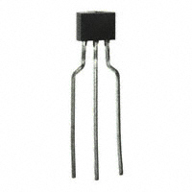  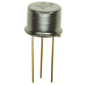  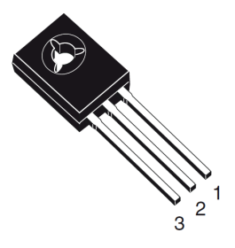  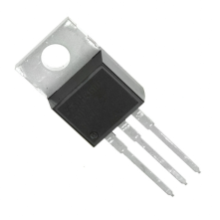  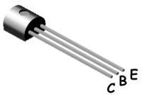  B  E  C  NPN  type  B  E  C  PNP  type  B  E  C
INTEGRATED CIRCUIT
There are a multitude of different integrated circuits (chips). Every year that goes by sees the birth of new ones. They are composed of a great number of basic components. They may therefore include resistors, transistors, diodes etc. Its number is written on the top. Its terminals are usually numbered like those pictured at right. The circular mark indicates terminal number 1. The notch indicates the extremity where the numbering starts and ends. |  | 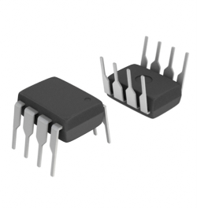  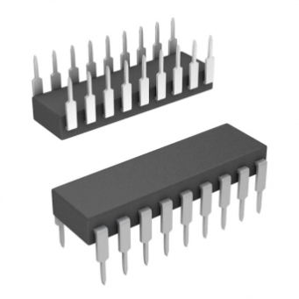  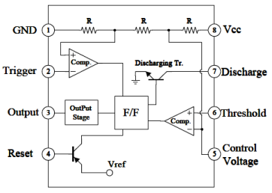  10  18  11  12  13  14  15  16  17  9  1  2  3  4  5  6  7  8  1  2  3  4  5  6  7  8 |  | 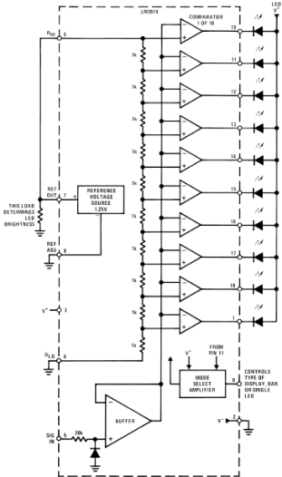

Can you recognise these components?
Using its letter, associate the name (in the center), to the symbol at left and to the photo at right.
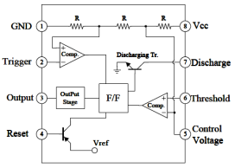
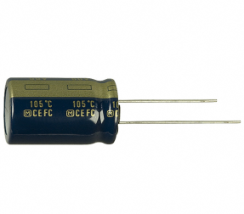
( ) | (A)  Fixed resistor | ( )
( )  +  _  Anode  Cathode | (B)  Variable resistor | 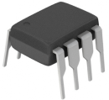  ( )
( ) | (C)  Ceramic capacitor | ( )
( ) | (D)  Electrolytic capacitor | 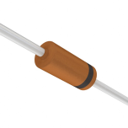  ( )
( ) | (E)  Ordinary diode | 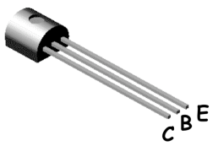  ( )
( ) | (F)  Light emitting diode | ( )
( )  +  _  Anode  Cathode | (G)  Relay | 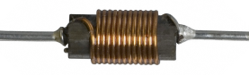  ( )
( ) | (H)  Solenoid | 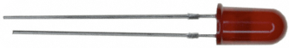  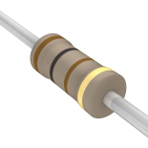  ( )
( )  B  E  C | (I)  Bipolar transistor | 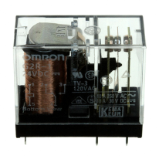  ( )
( ) | (J)  Integrated circuit | ( )

