Electronic Configuration
Na atom
Bohr Diagram

Lewis Dot

Electron Configuration--indicates orbitals that all the electrons occupy
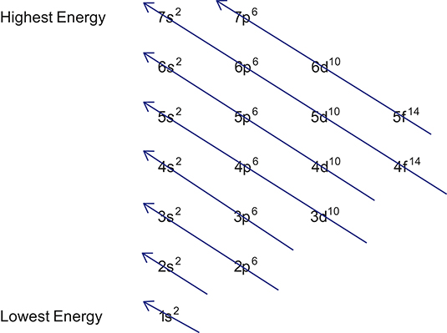

Orbits are Energy Levels or AKA Shells

Orbitals
- "rooms" on the Orbits (EL)
- orbitals can only hold 2 electrons spinning in opposite directions to compensate for the repulsion caused by the electrons both being negative
- only one s orbital per EL
- three p orbitals per EL--and you are only responsible up to 4s

Therefore for Na atom:

Therefore for Chlorine atom:

Can also be shown using up and down arrows to indicate the opposite spins of the electrons.

