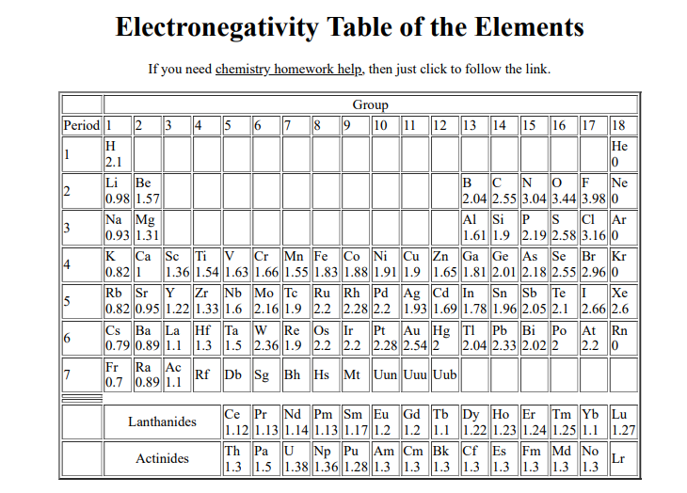
CHEMTEAM!!!!
This table is the Pauling electronegativity scale. There are other ways of measuring electronegativity, such as the Mulliken scale and the AllredRochow scale. Linus Pauling's electronegativity scale is the most common. Note that atoms toward the upper right are more electronegative, and those to the lower left are least electronegative. Pauling did not assign electronegativities to the noble gasses because they typically do not form covalent bonds.
In general electronegativity is the measure of an atom's ability to attract electrons to itself in a covalent bond.
Because fluorine is the most electronegative element, the electrons tend to "hang out" more toward the fluorine atom when fluorine is covalently bonded to other atoms. Oxygen is the 2nd most electronegative element.
When you examine a periodic table, you will find that (excluding the noble gases) the electronegativity values tend to increase as you go to the right and up. The reverse statement is that the values tend to decrease going down and to the left. This pattern will help when you are asked to put several bonds in order from most to least ionic without using the values themselves.
Electronegativity values are useful in determining if a bond is to be classified as nonpolar covalent, polar covalent or ionic.
What you should do is look only at the two atoms in a given bond. Calculate the difference between their electronegativity values. Only the absolute difference is important.
I. Nonpolar Covalent: This type of bond occurs when there is equal sharing (between the two atoms) of the electrons in the bond. Molecules such as Cl₂ , H₂ and F₂ are the usual examples.
Textbooks typically use a maximum difference of 0.2 - 0.5 to indicate nonpolar covalent. Since textbooks vary, make sure to check with your teacher for the value he/she wants. The ChemTeam will use 0.5.
One interesting example molecule is CS₂ . This molecule has nonpolar bonds. Sometimes a teacher will only use diatomics as examples in lecture and then spring CS₂ as a test question. Since the electronegativities of C and S are both 2.5, you have a nonpolar bond.
II. Polar Covalent: This type of bond occurs when there is unequal sharing (between the two atoms) of the electrons in the bond. Molecules such as NH₃ and H₂O are the usual examples.
The typical rule is that bonds with an electronegativity difference less than 1.6 are considered polar. (Some textbooks or web sites use 1.7.) Obviously there is a wide range in bond polarity, with the difference in a C-Cl bond being 0.5 -- considered just barely polar -- to the difference the H-O bonds in water being 1.4 and in H-F the difference is 1.9. This last example is about as polar as a bond can get.
III. Ionic: This type of bond occurs when there is complete transfer (between the two atoms) of the electrons in the bond. Substances such as NaCl and MgCl₂ are the usual examples.
The rule is that when the electronegativity difference is greater than 2.0, the bond is considered ionic.
So, let's review the rules:
1. If the electronegativity difference (usually called DEN) is less than 0.5, then the bond is nonpolar covalent.
2. If the DEN is between 0.5 and 1.6, the bond is considered polar covalent
3. If the DEN is greater than 2.0, then the bond is ionic.
That, of course, leaves us with a problem. What about the gap between 1.6 and 2.0? So, rule #4 is:
4. If the DEN is between 1.6 and 2.0 and if a metal is involved, then the bond is considered ionic. If only nonmetals are involved, the bond is considered polar covalent.
Here is an example:
Sodium bromide (formula = NaBr; ENNa = 0.9, ENBr = 2.8) has a DEN = 1.9.
Hydrogen fluoride (formula = HF; ENH = 2.1, ENF = 4.0) has the same DEN.
We use rule #4 to decide that NaBr has ionic bonds and that HF has a polar covalent bond in each HF molecule.
Special thanks to Craig Counterman from MIT who wrote the program and the script to produce this periodic table.

