Electrolysis of Water
Purpose:
- to decompose water
Materials and Method:
- sodium hydroxide or sulfuric acid—only to allow for the conduction of electricity in water—not part of the chemical reaction—not a catalyst!!
- Stirring rod
- Pieces of paper towel
- Wooden splints
- Matches

Label the diagram:

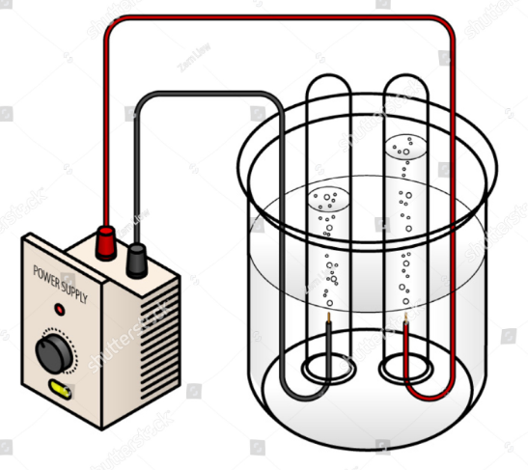
Observations:

Conclusion:
i)
ii)

Questions:

1) Chemical Formula of water _________________
Molecular Structure of water

2) BCE for the electrolysis of water:

______________________________________________________________________

3) Draw the BCE for the electrolysis of water:

4) i) What type of reaction is this? ___________________________________

ii) How do you know that it is this type of reaction? _______________________

________________________________________________________________

________________________________________________________________

5) What were the differences between the cathode (-) terminal and the anode (+) terminal?

_i)____________________________________________________________________

_ii)____________________________________________________________________

6) Why were there differences between the 2 electrodes?

____________________________________________________________________________

____________________________________________________________________________

7) Draw – blow up diagram – what was in each test tube:

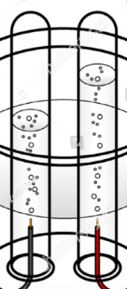

8) Real world application of electrolysis of water: _____________________________

______________________________________________________________________
______________________________________________________________________

