Statement of Inquiry:

Technological innovations often alter the relationships people have with their local and global environments.

Key concept: relationships

Related concepts: development, environment

Global context: Globalization and Sustainability (consumption, conservation, natural resources and public goods)

Debatable Question:

Hydroelectricity and the Province of Quebec—What price have we paid??

Electricity

Electricity is the presence and flow of electric charge. Its best-known form is the flow of electrons through conductors such as copper wires.

Electricity is a form of energy that comes in positive and negative forms, that occur naturally (as in lightning), or is produced (as in generator).

Electricity - Simple English Wikipedia, the free encyclopedia https://simple.wikipedia.org/wiki/Electricity

Things That We Use That Need Electricity

In the Morning | During the Day | At Night

The Atom

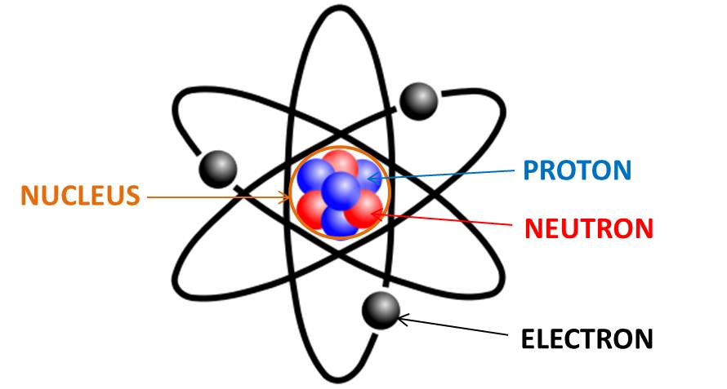

Particle | Symbol | Charge | Mass (amu) | Location

Charge

- Electrons are free to move under the influence of an outside force—either physical or electrical

- Electrons are held relatively held loosely in conductors such as

___________________ AND ___________________

- Electrons are held more tightly in insulators such as

___________________

___________________

___________________ etc

Static Electricity Current Electricity

- Too many electrons around the atoms of an object causes the object to have a negative charge—excess electrons.

- Too few electrons around the atoms of an object causes the object to have a positive charge—too few electrons.

Freed electrons are the stuff of which electricity is made!!!

Voltage

- The "pressure" that makes the electrons flow along a conductor (wire)

e.g. 9 Volt battery

e.g. 120 Volt power lines in your home

- Symbol is ____________________

- Unit is the _____________________________________

- Measured using a Voltmeter ______________________ = the "social reject"

AKA _____________________________________

_____________________________________

_____________________________________

Current

- The flow of electric charge

- The charge is carried by moving electrons along a wire

- Current is the flow of electrons along the surface of a wire.

- Like a liquid that flows through a pipe

- If there is a lot of water in the tank—there is more pressure for the water to be pushed through the pipe

- Symbol is _____________________________

- Unit is ________________________________

- Measured using an Ammeter ________________ ton Amie!

Resistance

- A measure of how hard it is for electric current to move along a conductive material.

- Symbol is ________________________

- Unit is ___________________________

- Measured using an Ohmmeter which we do not have!

- Or calculated using Voltage and Current

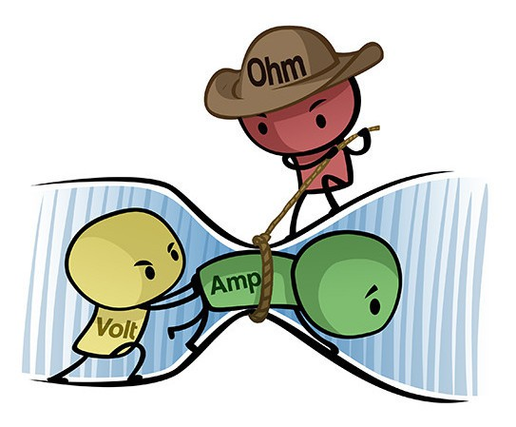

No conductor is a perfect conductor and no insulator is a perfect insulator!
All materials put up some resistance to electrons flowing!

Activity: Lighting Up a Light Bulb

Equipment
- wire--lead
- light bulb
- D battery

How did you light up the light bulb?
Sketch

