Electrical Engineering ERPI Questions

1. What are the main differences between electrical components and electronic components?

2. What is the difference between AC and DC?

3. Which way do electrons flow?

4. Why are electrical wires covered in plastic??

5. What kind of circuit is used to save space inside a computer?

6. What is the electrical function of a circuit breaker?

7. A resistor has the following colour bands:
Yellow----------Violet----------Orange----------Gold

What is the value of the resistor? ________________________________________

8. A resistor indicates 47 000 Ω +/- 5 %.

What are its colour bands? ________ ________ ________ ________

9. What is the name of this device? _______________________
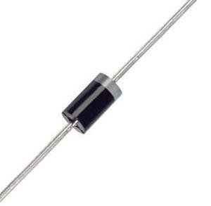
Draw the symbol for this device.
Indicate which end is positive and which end is negative on the symbol and on the image.
10. What is the name of this device? ________________________
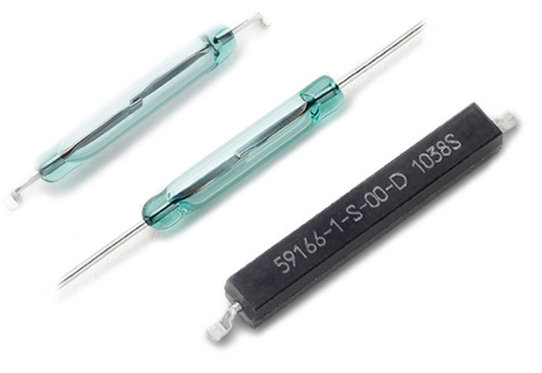 | 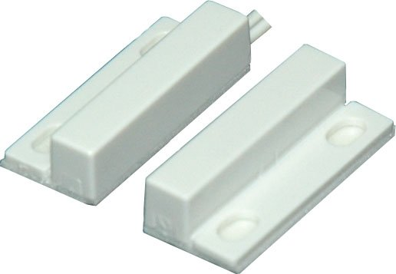

When would it be used? _______________________________________________

______________________________________________________________________

11. Choose and sketch the appropriate switch for the following functions:

i) opening and closing 2 contacts at once _____________________________

ii) opening one or the other of 2 circuits _____________________________

12. Name the electrical function of the device:

i) doorbell _____________________________

ii) battery _____________________________

iii) the plastic covering on a mouse _____________________________
iv) 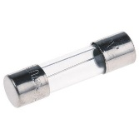 _____________________________

13.
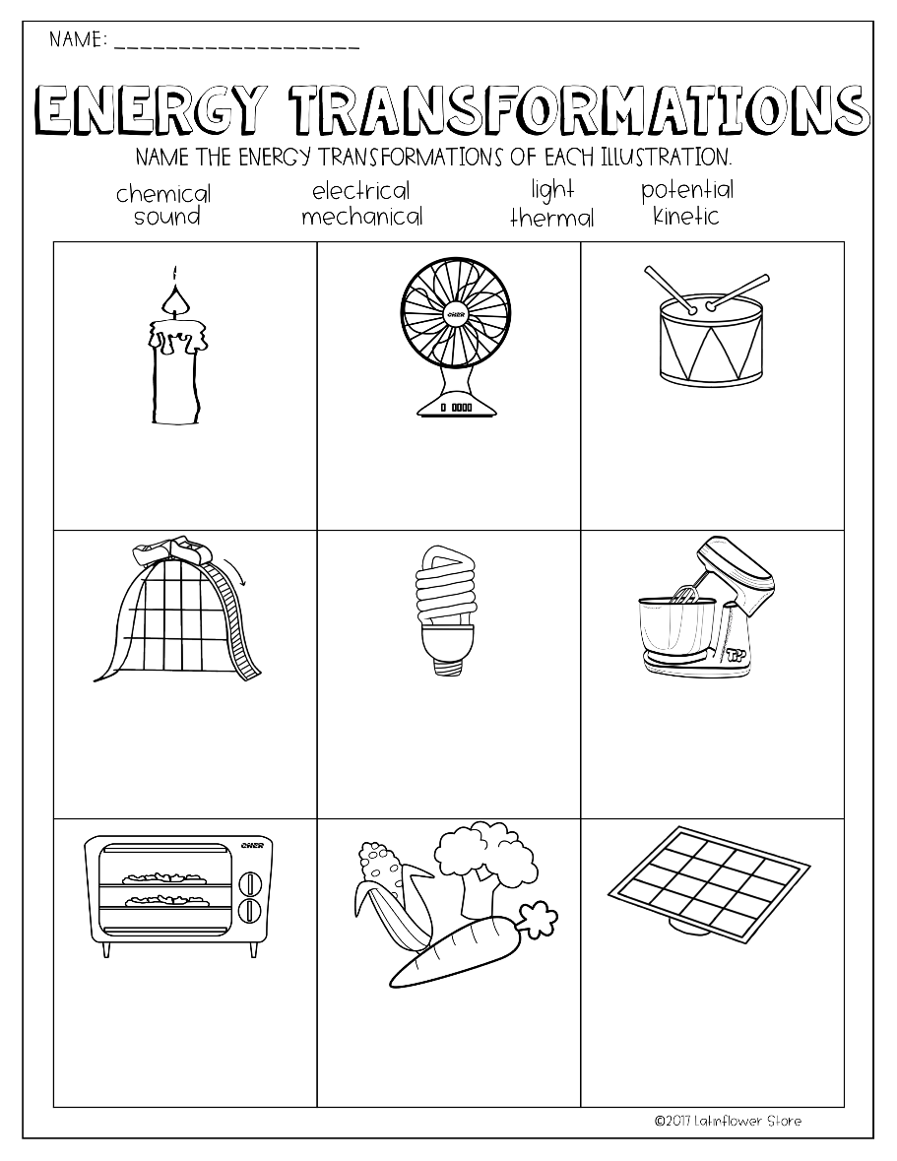

14. 