Earth and Space--The Lithosphere
The Lithosphere
- a hundred km outer shell of the Earth
- crust and upper mantle
- rocks and minerals
- building materials, metals, precious jewellery stones
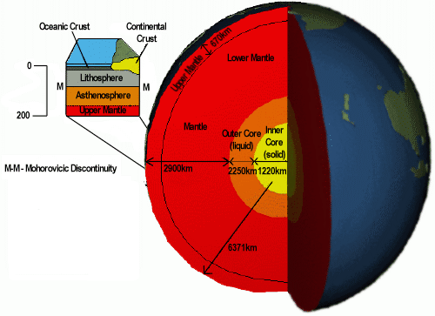
Soil
- relatively thin surface layer of the Earth's crust consisting of mineral and organic matter that is affected by agents such as weather, wind, water, and organisms

- at risk--we do not have enough of it
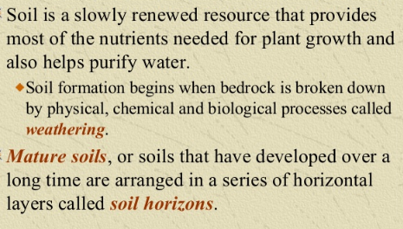

Buffering Capacity of Soil

- soil acidity or pH can vary from very acidic to very alkaline (basic)

- either end of pH scale hinders plant growth

- plants like pH 6-7

- conifers like more acidic

- soil can neutralize a certain amt of acidity or alkalinity without its pH changing

- soils can compensate somewhat for variations in pH

- the ability to resist changes in its pH when acidic or alkaline compounds are added to it is called its buffering capacity

- the finer the texture the better the buffering capacity

Summarize your lab results with water, sand and soil:
Data Table

What does each of the results mean?

Permafrost
- in Northern regions large expanses of soil are permanently frozen

- permafrost is ground whose T has been 0 ºC or lower for at least 2 years

- almost 50 % of land in Canada

- less than or equal to 500 m deep

- at high altitudes too -- so can be found on mountains

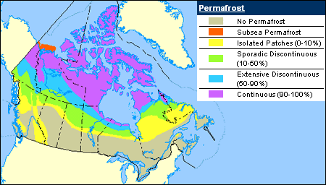

- top layer AKA the active layer sometimes thaws in summer

- houses have to be built on piles that pass through the active layer and sit directly on permafrost

- the active layer is very sensitive to T fluctuations

- global warming has wreaked havoc with the permafrost

Permafrost Video
https://www.youtube.com/watch?v=2w4UQfJHD-A

Lithosphere Energy Resources

- oil, natural gas and coal resources

- fossil fuels, Uranium, geothermal

Fossil Fuels
- 2/3 of world’s electricity from FF

- oil (a liquid) from small marine animals and algae in sea which died, sank and covered with rocks and minerals

- pressure turned them into oil or natural gas

- coal (a solid) from terrestrial plants and trees in swamps

- burn to emit thermal energy → mechanical energy → electrical energy

Combustion:

- emits carbon dioxide = chief greenhouse gas

- sulfur dioxide and nitrogen oxides = acid rain

- methane = 21 x more powerful greenhouse gas than CO₂

Uranium
- radioactive element that occurs naturally

- splitting (fission of) the nucleus produces large amts of energy → electricity

- a handful U = same amt of HE as 70 000 kg of coal

- fission = splitting

- no greenhouse gases

- huge amount of energy stored in the bonds btw the particles in the nucleus of an atom

- heat energy AND radioactivity released

- containment buildings of reinforced concrete
- buildings supposed to be earthquake resistant (Fukushima Japan, 2011)

- radioactive waste last for hundreds of years

- cool in huge pools, buried in mines or concrete pits

- 1 plant only in Gentilly QC

Geothermics
- molten rock contains enormous amts of energy (earth and hot)

- internal heat of the earth

- fluid is circulated deep underground

- it heats up and rises to the surface

- converted to electricity or used to heat buildings

- volcanic regions where hot rock is near surf

- hot water rises to the surface by itself

- reduce heating costs and CO₂ emissions

- renewable

- installation is very expensive

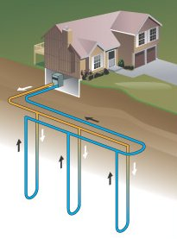

Energy of Tomorrow?????
- fossil fuels = non-renewable = will run out in the next few decades (your lifetime!!!!!)

- hydrogen cells instead?

- H₂ is most abundant element on the earth

- lit splint test = H₂ gas explodes -- pops and goes out = heat energy released

Pollution and Degradation

Soil Depletion
- farming practices use heavy machinery that compact soil (removing oxygen)

- compaction prevents rain from penetrating the earth

- rainwater runs off the surf into lakes and rivers carrying organic matter, microorganisms and essential nutrients for plant life

- loss of soil fertility

- need to let land rest

- crop rotation instead and lots of fertilizer and pesticides

Eutrophication

fertilizer → run off → growth of algae in lakes (cyano-bacteria = blue-green algae in QC)

Bioaccumulation

pesticides → accumulate in tissues of organisms → kill microorganisms, insects and small animals
- organisms are needed to maintain balance

- biodiversity threatened
Contamination
- gas station leaks of hydrocarbons

- landfills leak water containing heavy metals

- mining spreads acid residue

- contamination is the abnormal presence of a harmful substance in the environment

- precipitation carries all kinds of chemicals

- sulfur dioxide and nitrogen oxides from factories and fossil fuel combustion become mixed with ppt

- sulfuric acid and nitric acid form acid rain

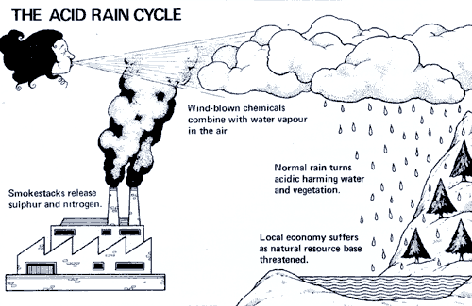

- acidified soil can no longer retain nutrients essential to plant life

- acid rain kills microorganisms beneficial to plants

- trees and plants grow more slowly and soils with low buffering capacity are affected

