Earth and Space
The Hydrosphere
- more than 2/3 of earth is covered by water

- underground (liquid), in the atmosphere (gas) and glaciers (solid)

- Earth = the Blue Planet

- the layer of water = the hydrosphere

- S, L and G

- only 2.5 % is freshwater and 79% of that is frozen in glaciers

- freshwater is found on the continents as opposed to the oceans

- fresh water is found in rivers, lakes and groundwater

Watersheds
- are catchment areas or drainage basins

- an area of land whose lakes and rivers all empty into the same larger body of water

- there are natural boundaries called watershed divides

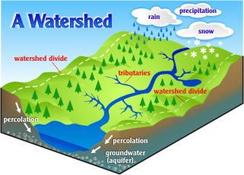
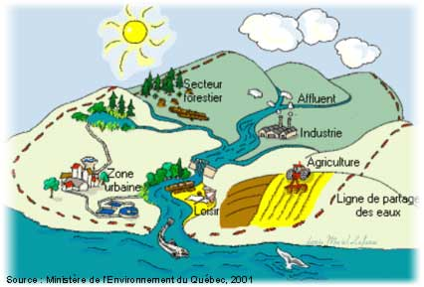

- the natural slope of the land causes the water to flow in the same direction

- 3 main watersheds in QC: 1) St. Lawrence River
2) Hudson Bay
3) Ungava Bay

Factors that slow down or speed up water flow in a watershed

- topography or the shape, slope and terrain

- geology or the type, depth and structure of rock

- climate or the rain or snowfall, winds and temperature

- vegetation or the density and diversity of plant life

- agricultural, industrial and urban development

Why are Watersheds so important?
- Humans use the rivers or streams contained in a watershed for drinking water, irrigation, transportation, industry and recreation.

- They provide habitat for plants and animals.

- The rivers drain into lakes and into the ocean.

- They are a beautiful part of the natural world.

Water Contaminants
- may be naturally occurring or man-made

- chemical contaminants include nitrogen, bleach, salts, pesticides, metals, toxins produced by bacteria, and human or animal drugs

- biological contaminants are organisms in water--microbes or microbiological contaminants

- find their way into the water supply from different sources

- indirect sources include contaminants that enter the water supply from soils/groundwater systems and from the atmosphere via rain water

- soils and groundwater contain the residue of human agricultural practices (fertilizers, pesticides, etc) and improperly disposed of industrial wastes and waste

Oceans
- there are 5 = Pacific, Atlantic, Indian, Arctic and Southern

- seas are closer to coastlines e.g. Mediterranean Sea

``Many people use the terms "ocean" and "sea" interchangeably when speaking about the ocean, but there is a difference between the two terms when speaking of geography (the study of the Earth's surface). Seas are smaller than oceans and are usually located where the land and ocean meet.`` Wikipedia

Factors that influence water T
Depth
Seasons
Latitude
Salinity

- Depth

- sunlight penetrates and warms the upper layer

- the highest layer is a mixed layer

- the depth varies depending on wind, tides and turbulence
- water T falls rapidly below the 200 m mark

- the thermo-cline layer = 200-1000 m = transition zone

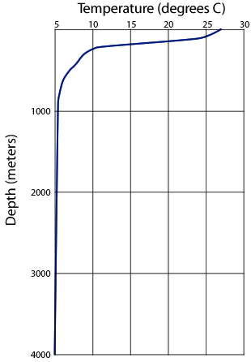

- deep water

- ocean floor

2. Seasons
- in the winter the oceans loses some of its heat energy it stored during the summer

- water loses heat more slowly than land (high specific heat capacity)

- therefore seasonal differences are less pronounced at sea

3. Latitude
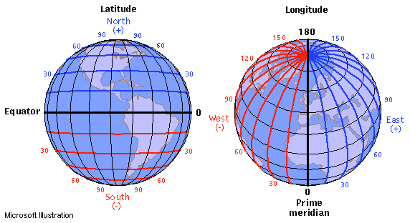

- at the equator the average temperature is 25 - 28 ºC

- in temperate zones i.e. us in Montreal the average temperature is 12-17 ºC

4. Salinity
- seawater pounds against the rocks of the lithosphere and dissolves salts

- rivers and groundwater dissolve salts and carry the salt to the ocean

- 3.4 - 3.7 % m/v salinity

- is a measure of the amt of salt dissolved

- at the poles, melting ice dilutes it to 3 %

- at the Red Sea evaporation increases concentration to 4 %

Ocean Circulation
- water is constantly moving hence we have waves and tides

- ocean current is the movement of seawater in a certain direction

- there are surface currents and subsurface currents

- ocean circulation is the combined effect of all the currents

Surface Currents

- are wind-driven

- move horizontally first 400 m below

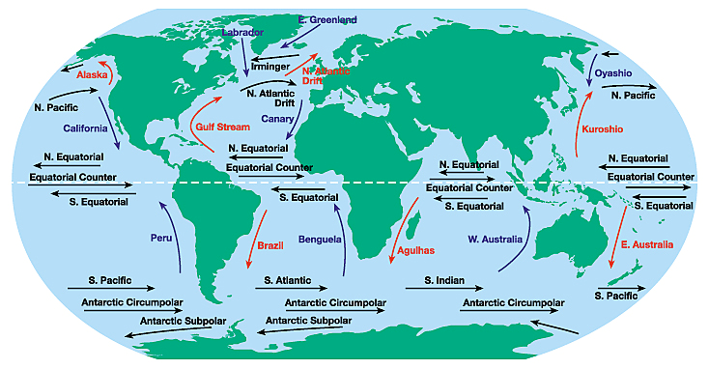

- Quebecers have the Gulf Stream = very important for our weather!!!!!!

Subsurface Currents

- at a depth greater than 800 m winds no longer have an effect

- there are variations in density of water layers

- the denser the water the deeper it sinks--below water that is less dense

- density varies with T

- the colder the more dense _______________________________________________

- there are variations in salinity

- the higher the salinity the more dense ___________________________________

- salty water tends to sink below less salty water

Salinity Experiments
https://www.youtube.com/watch?v=t4kJUmt7rjc
Experiment 1

Experiment 2

Thermo-haline Circulation

- surface and subsurface currents form a “conveyor belt”

- this moves water around the world

- it is responsible for major transfers of heat

- it lessens the difference btw the equator and other locations = yay for us!

The Cryosphere

- where water is found as a solid

- pack ice, glaciers, frozen lakes and rivers, snow, ice in permafrost

Pack Ice

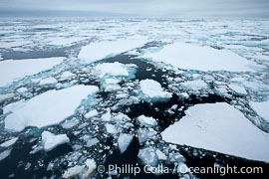

- Arctic and Antarctica

- huge slabs of ice on surface of the water and crash into each other

- smaller, free-flowing pieces = ice floes

- ice expands and contracts with the seasons

- in the winter = 12 million square kilometers

- signs of weakening because of global warming

- major problem in the summer especially for animals

Glaciers

- do not float on water!!!!!!!!!!!!!

- they lie on land!!!!!!!!!!!!

- some on mountain peaks

- Greenland and Antarctica are the most impressive

- large ones are ice caps and ice sheets

- they contain 79 % of freshwater

- snow accumulates on surf of glaciers and compacts to ice

- pieces of ice break off on the sides = icebergs

- global warming = melting of ice = slippery around and under glacier therefore less stable

- ice falling into ocean increases water level

- sea level locations in danger

- thawing increases freshwater into Norwegian Sea--mixes with Gulf Stream

- less saline = less dense = less sinking = slowing of ocean currents therefore climate change

Energy Resources
- the force of moving water represents a tremendous source of energy

- hydraulic energy

Water from Rivers and Waterfalls = Hydroelectricity
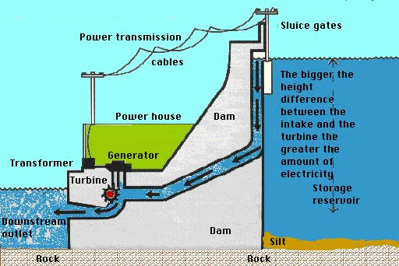

- rate of flow of rivers in QC generates our electrical energy

- a dam is built

- the dam gates are opened

- the water rushes into large pipes that lead to the turbine

- the force of the water spins turbines which are connected to alternators (generators) that convert the mechanical E to electric current

- depends on renewable resources

- impacts environment because

- bioaccumulation of methyl-mercury as it moves through food chains and food webs

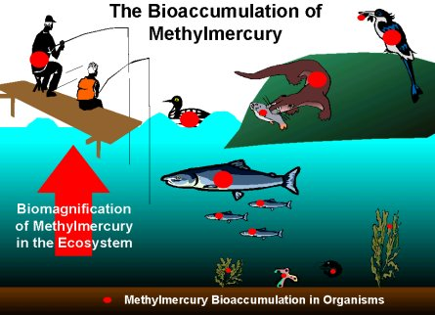

Waves and Ocean Currents

- buoys that rise and fall with waves creating movement that turns turbines

- underwater turbines

Pollution and Degradation

- human activities = domestic, industrial, agricultural or navigational

- endangers quality of drinking water, health of ecosystems and beauty

- factories discharge warm water into rivers = raises the T and reducing the concentration of O₂ = thermal pollution

Contamination and Eutrophication of Natural Waters
- different sources of pollution

- point sources -- traced to a well-defined site

- rain is loaded with atmospheric contaminants from factory smokestacks hundreds of km in any direction

- living organisms can degrade certain contaminants and therefore maintain balance

- the health of LOs depends on temperature, oxygenation and chemical composition of the water

- some contaminants are not biodegradable e.g. plastics

- pollution = unbalanced ecosystem

- contaminants accumulate

- the more toxic and concentrated the more harmful

- farming activities = excess fertilizers and pesticides run off into rivers and lakes = increase algae growth = eutrophication

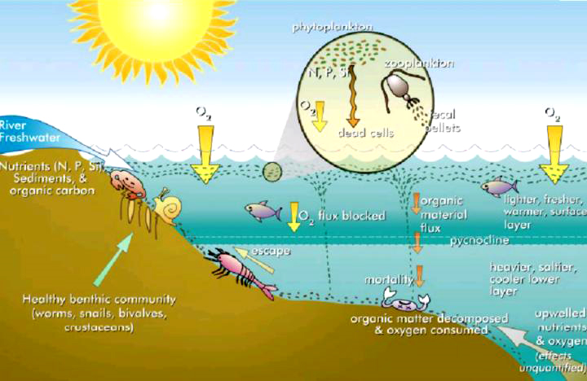

Eutrophication

- excess fertilizer runs off into a water supply

- algae blooms--blocks off sunlight--plants die

- natural waters lose their O₂ because of an excessive accumulation of organic matter and nutrients

- dead algae sink to bottom and are decomposed by bacteria

- the bacteria use lots of O₂ to decompose the algae

Threats at Sea

- approx. 6 million tonnes of petroleum are discharged into oceans every year

- mostly off-shore drilling (only a bit from accidental oil spills)

- oil tankers clean out their reservoirs in the open sea

- hydrocarbons float on the water’s surface and pollute the coastlines

- coat the bodies of marine animals and poisons them

- it can take years for pollutants to decompose

