Name:___________________________________

Partner: _________________________________
The Effect of 2 Different Chemicals on Daphnia Heart Rate

Objective: i) To determine how Redbull affects the heart rate of Daphnia.

ii) To determine how ethanol affects the heart rate of Daphnia

Materials:

- Daphnia ______________________________ ( genus and species name)
- Depression slides
- 10 % -- 20 % -- 30 % v/v aqueous solns of Redbull

- 5 % v/v ethanol Chemical formula = _____________________________

Structural formula =
- Lens paper
- Stereoscopes or Light microscopes
- Stopwatch

Procedure

- Obtain a depression slide with a Daphnia in water.
- Let the Daphnia rest for one minute.
- Using a lens paper, remove most of the water from the slide so the Daphnia does not have too much room to move around.
- Place the slide under stereoscope or microscope. DO NOT TURN ON THE MICROSCOPE UNTIL YOU ARE READY. Otherwise the Daphnia will cook!
- Turn on the microscope and observe the animal under LOW POWER.

The beating heart is located on the dorsal side just above the gut and in front of the brood pouch (see diagram). Make sure that you are counting the heart beats, and not the flapping of the gills or movements of the gut. The heart must be observed with transmitted light if it is to be properly visible.
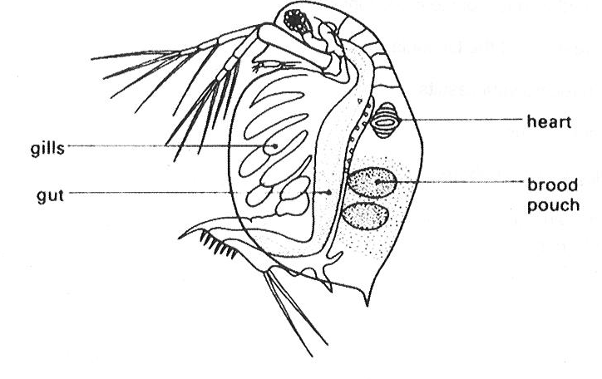

- Count the number of heartbeats in 20.0s -- make dots on a paper to help you keep track as per the Carolina Biologicals Video.

- Repeat steps 1-6 for Daphnia in 10 %, 20 %, and 30 % Redbull and 5 % alcohol solutions.

Data

Solutions | Heart Rate (for 20s) | Heart Rate (beats/min)
10 % Redbull

20 % Redbull

30 % Redbull

5 % Alcohol

Questions

1. What are the variables in this lab?

Variables | Redbull | Alcohol
Independent

Dependent

Controlled

2. Graph the data.

3. What was the reason you did STEP 6?

4. How was the heart rate affected by the Red Bull?

Why?

5. How was the heart rate affected by the alcohol?

Why?

6. Compare the heart rate of your Daphnia before the experiment with the heart rate from the other Daphnia in your lab.

How much variability is there among trials for individual water fleas?

-------------------------------------------------------------------------------------------------------------------------------

-------------------------------------------------------------------------------------------------------------------------------

7. Why is it necessary to repeat the experiment on several individuals, rather than repeating it on the same individual again and again?

____________________________________________________________________________

____________________________________________________________________________

8. What about Daphnia make it so easy to experiment on for a scientist?

-------------------------------------------------------------------------------------------------------------------------------

-------------------------------------------------------------------------------------------------------------------------------

9. Why are Daphnia such a great food source for fish?

-------------------------------------------------------------------------------------------------------------------------------

-------------------------------------------------------------------------------------------------------------------------------

10. Where are Daphnia’s natural habitat?

-------------------------------------------------------------------------------------------------------------------------------

-------------------------------------------------------------------------------------------------------------------------------

11. Why is Daphnia magna the most used source of Daphnia?

-------------------------------------------------------------------------------------------------------------------------------

-------------------------------------------------------------------------------------------------------------------------------

