Cormier Practice Questions--Materials and Tolerance

1. Do the following statements describe the degradation (D) or the protection (P) of a material?

a) A wooden patio is treated with an antifungal coating. _____
b) The plastic pot that was left out all winter has cracks all over its surface _____

2. What can be done to protect a metal nail from corrosion?

3. What is the main degradation problem ceramics?

4.
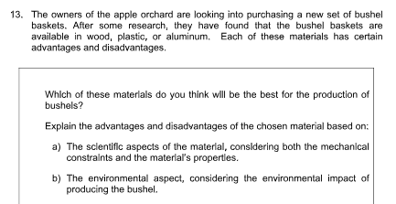

5. Can a stick that has a diameter of 60.5 mm ± 1.0 fit in a hole that has a diameter of 61 mm ± 0.1 mm?

6. A company ordered a part that had a square side of 84 mm ± 3 mm. It received a part that has a side of 80. mm. Should the company accept the part?

7. What should be the smallest acceptable tolerance on a 65 mm peg so that it may possibly fit in a 60 mm ± 2 mm hole?

8.
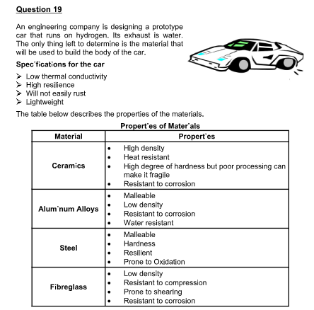
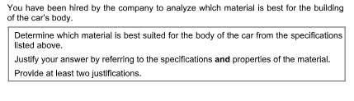
9.
