Cobalt chloride Test for Water
https://www.youtube.com/watch?v=YGdArTxQVq0

Anhydrous form (without water) = BLUE
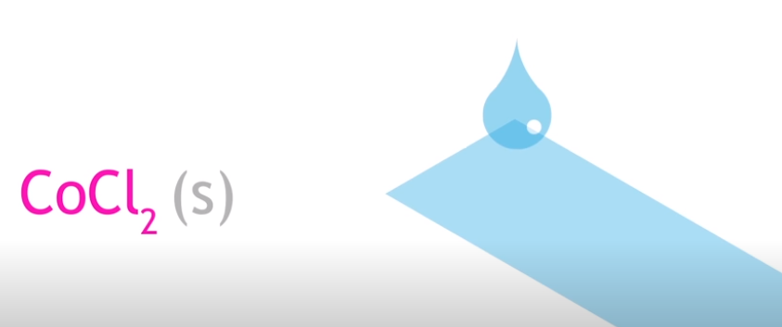

Hydrated form (with water) = PINK

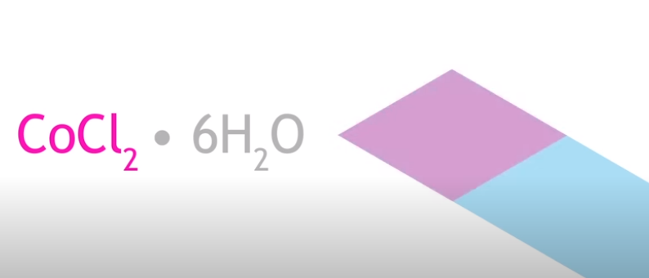

Le Chatelier and Cobalt Chloride
https://www.youtube.com/watch?v=JyJrgc8XgVA – slowest video ever!!

When cobalt (2) chloride dissolves in water it establishes an equilibrium involving 2 differently coloured complex ions.

The two different coloured Co(2) complex ions, [Co(H₂O)₆]²⁺ and [CoCl₄]²⁻, exist together in equilibrium in solution in the presence of chloride ions according to the following equation:

Heat E + [Co(H₂O)₆]²⁺(aq) + 4Cl⁻(aq) ⇌ [CoCl₄]²⁻(aq) + 6H₂O(l)

Hydrated Form Anhydrous Form
PINK BLUE

Keq =

