How to Write Electrolytic Dissociation Equations

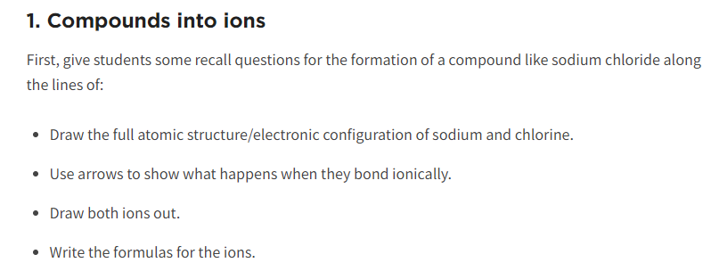
Example: Sodium chloride

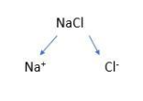

Equation: __________________________________________________________________

What would it look like with 2 NaCl??

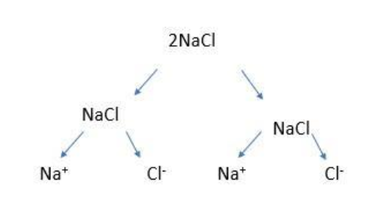
Equation: ___________________________________________________________________

What about sodium oxide?

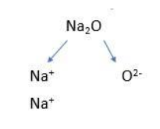
What about 3 sodium oxide?

Polyatomics?

Barium hydroxide:

Aluminum sulfate:

2 Lead (II) nitrate:

