Chapter 11 Genetics
Character Traits
- are physical, psychological or physiological attributes that may vary from one individual to another within the same species
Chromosomes
- eukaryotic cells contain a nucleus that contains chromosomes (coloured bodies because they stain)
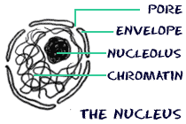

- hold the basic genetic info

- chromatin = 1 molecule = 1 chromosome of DNA wrapped around protein balls (histones)

- chromatin is a mass of DNA and proteins within the nucleus of most cells not undergoing division (mitosis)

1 strand of DNA = 1 chromosome

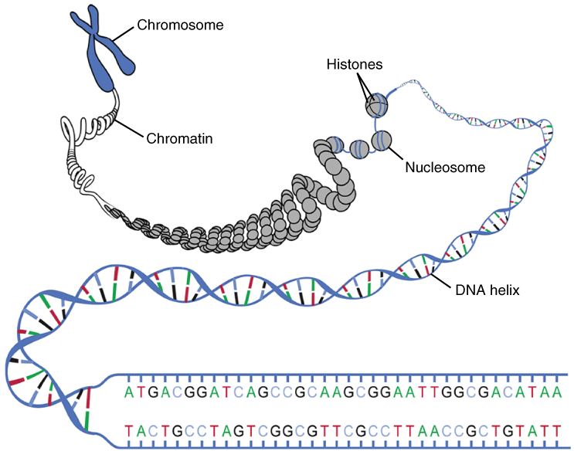

- when the cell is set to divide to reproduce or form sex cells (gametes) the chromatin contracts and becomes chromosomes

- humans have 46 chromosomes = 23 pairs = 22 autosomes and 1 sex pair

- chromosomes can be classified according to size and distinctive features (bands, placement of centre)

- homologous chromosomes = matching chromosomes e.g. a pair of chromosome 21

- an ordered representation of a person's chromosomes = a karyotype

- sex chromosomes are not the same size in boys = x and y homologous chromosomes

Karyotype

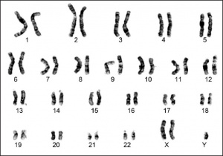

What's the problem with the above karyotype? ____________________________

Homework tonight = go to this website and do the activity
http://www.biology.arizona.edu/human_bio/activities/karyotyping/karyotyping.html

Amniocentesis
- a procedure performed on a pregnant woman approx. 4 months gestation
- a needle is inserted through the abdominal wall into the uterus
- fetal cells floating in the amniotic fluid are removed
- the cells are grown up (tissue culture in vitro)
- the DNA = chromosomes are obtained from the cells
- a karyotype = a picture of the chromosomes is made
- some genetic defects can be determined this way e.g. trisomy 21 = Down's Syndrome
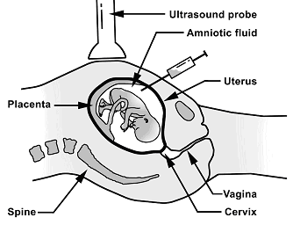

DNA and Genes
- each chromosome is made up of DNA

- DNA is shaped like a twisted ladder = a double helix

- DNA is a polymer = a long molecule made up of repeating units (nucleotides = PSB)

- 1 nucleotide = 1 PSB = a phosphate--deoxyribose sugar--nitrogenous base (A or T or G or C)

- phosphate--sugar backbone = the sides of the ladder

- base pairs = the rungs of the ladder

- Guanine--Cytosine and Adenine--Thymine = complementary base pairs in DNA

- a particular sequence of base pairs = 1 gene

- 1 gene codes for 1 protein

- all of our genes from mummy and daddy = our genome

- we have thousands of genes

- genes = the blueprint instructions for making proteins = brown skin, blue eyes, pointy nose!

- 1 gene = a DNA segment that contains info for making 1 protein

- 1 different base pair may mean 1 different amino acid which means a different shape to the protein = could be a major difference or not

DNA segment in the nucleus (too short to be a gene)

A G C T T A G C T C A

Complementary Strand of mRNA made in the nucleus and sent into the cytoplasm

tRNA

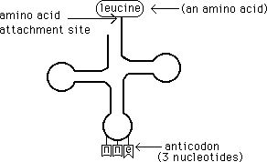

Proteins

- your proteins determine who and what you are!!!!!

- a protein is a molecule that plays a specific role in the functioning of an organism and in the expression of its character traits

Task | Example
Support | Elastin makes the skin firm yet elastic
Transport of substances | Hemoglobin Hb carries oxygen O₂ in the blood
Control and message relay | Hormones control cell functions and relay messages e.g. insulin helps control the amount of sugar in the blood  e.g.growth hormone or testosterone
Immunity | Antibodies protect us from disease
Catalysis | Enzymes speed up biochemical reactions e.g. amylase breaks down starch to make digestion faster

Protein Structure

- there are over 100 000 proteins making up your body

- the shape of the protein determines what is does

- proteins are molecules made up of one or more chains of amino acids

- proteins are polymers = long molecules of amino acids

- there are 20 essential amino acids = animal food sources e.g. cow muscle = red meat has all 20

- the types of the amino acids and the sequence of the amino acids determines the shape of the protein e.g. my hair versus someone with straight hair

- an amino acid is a molecule that can combine with other amino acids to form proteins

- change the shape = change the function, colour etc

1 protein

Protein Synthesis

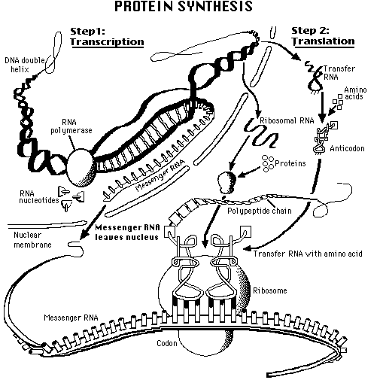
- DNA to protein = protein synthesis
- transcription of DNA and translation into protein

Transcription (in the nucleus)

- DNA has a long chain of base pairs

- 3 base pairs = 1 codon = the code for 1 amino acid

- DNA unzips to expose a gene
- 1 side of the DNA is copied by an enzyme

- this makes a copy of the DNA called messenger RNA (ribonucleic acid) mRNA

- mRNA has copied the long chain of bases

- 3 bases = 1 triplet = 1 amino acid

- mRNA contains G, C and A but T is replaced by U = uracil

- the mRNA leaves the nucleus through a pore in the membrane and enters the cytoplasm

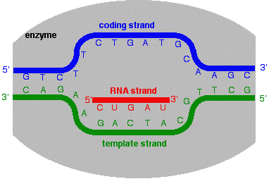

Translation (in the cytoplasm)
- the mRNA attaches itself to a ribosome in the cytoplasm

- the ribosome slides over the mRNA and reads triplets of bases on the mRNA

- each triplet codes for an amino acid = the genetic code!!!!!

- the amino acids are brought to the ribosome by transfer RNA (tRNA)

- the tRNA carry 1 triplet complementary to the triplet on the mRNA plus 1 amino acid

- the amino acids are linked together as they are brought in one by one

- there are start codons and stop codons that tell the ribosome to start and stop making a protein

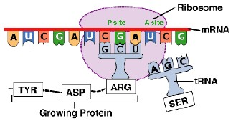

mRNA code for amino acids

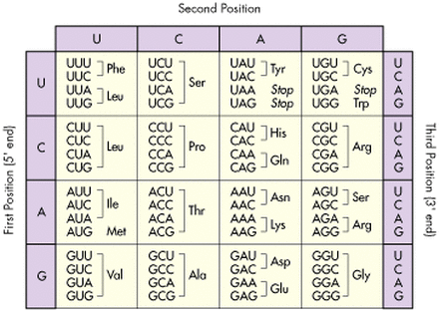

Mutations

- 1 base pair too many

- 1 base pair lost

- 1 base pair different = point mutation

- additional sections of base pairs

- deletions of sections of base pairs

- messes up the sequence and the shape of the protein

- maybe it functions; maybe it doesn't

- thank the chemistry gods or whomever for your good fortune!!!!!!!!! be grateful for what you've got!!

