Electrical engineering
CHAPTER 14

Concept evaluations by chapter

EST
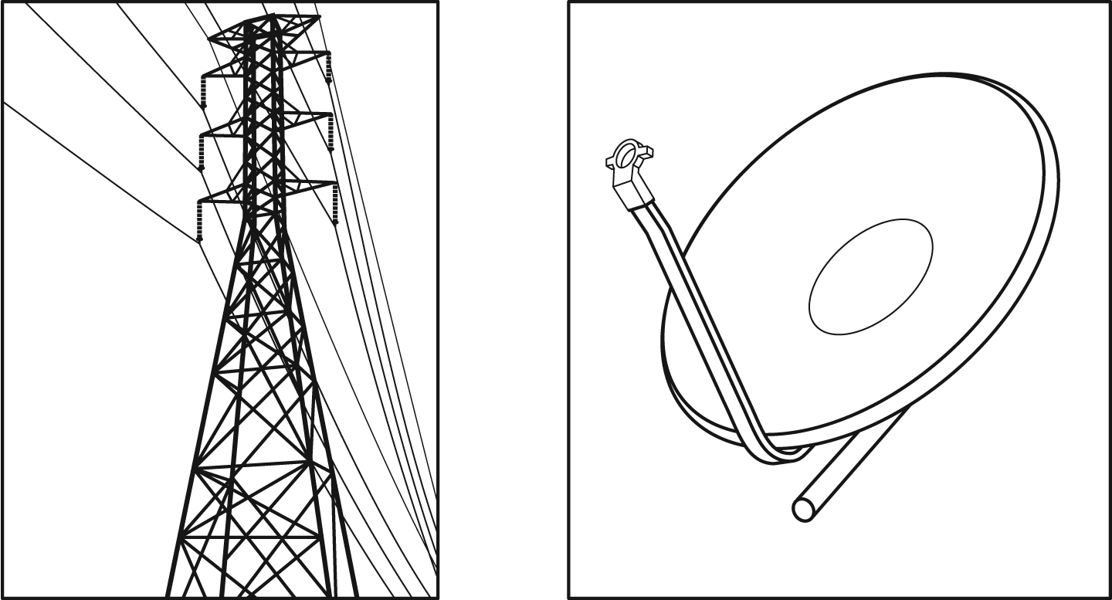
To answer question 3, students must have covered the concepts in Chapter 5.
1. Each of the illustrations below suggests a field of application of electrical engineering. Name the types of systems represented.
A B

A.
B.
[ /2]
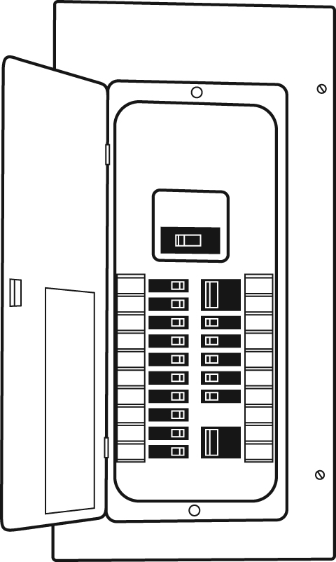
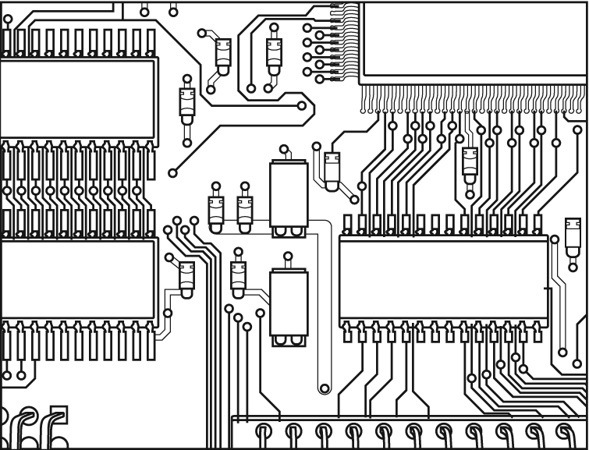
2. Look at the two illustrations below.

A B
a) These objects clearly illustrate the two main areas of electrical engineering. What are these areas?
b) Describe three differences in component design in these two areas.
c) Which device performs the electrical function of protection in illustration A?
d) Which two materials are commonly used to manufacture the support for the components in illustration B?
[ /9]
3. In the lab, you have been given the
following materials: a battery, three lamps,
two switches and a fuse.
a) You must assemble a circuit containing
the battery, one switch and the three
lamps. The lamps are to be connected
in parallel, and they must all turn on at
the same time and give off the same
intensity of light. The fuse must be
installed so that the total current intensity
does not exceed 2.4 A. Draw the diagram
for this electrical circuit.
b) What would happen if the current in the circuit in question a) were to exceed 2.4 A?
c) With the same materials as in question a),
how could you assemble a circuit to turn
on one lamp, then two lamps and finally
three lamps, all giving off the same
intensity of light?
Draw another diagram for this new circuit
and describe how it works.
[ /9]
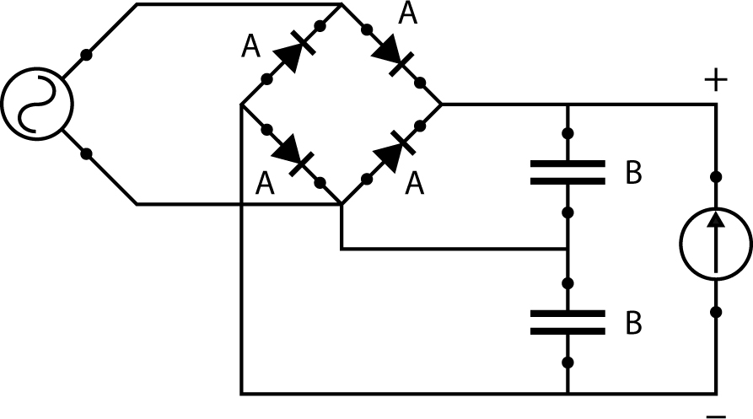
4. The diagram opposite represents a “voltage
doubler.” For example, it can be used to increase
voltage from 10 V to 20 V.
EST

a) Identify elements A and B in this circuit
assembly and explain their respective roles.
b) Describe the movement of electrical charges as they enter and exit the doubler.
[ /4]
5. Every year, Andy has his students build a "soapbox" car. This year, Barry’s team has designed a braking system, but Andy has asked them to change it so that the rear lights come on as soon as the driver steps on the brake pedal. For the next class, each of the team members is supposed to think about this and find a way to build such a system.
Maude proposes the following approach at the team’s next meeting:
“We are going to cut an iron washer into two equal parts and glue two flat elastics across the halves to hold them together, with no more than 0.5 cm between them. We will find a metal nail 15 cm long and 0.6 cm in diameter and cover the end with melted plastic. Then, we will attach the nail to the brake pedal so that its end passes between the halves of the washer. We will solder a wire to one half of the washer and connect it to the terminal of a 6.0-V battery. We will solder another wire to the other half of the washer and connect it to the rear brake light system and to the other battery terminal. When we step on the brake pedal, the nail will move through the hole in the washer, stretching the elastics, and the lights will turn on.”
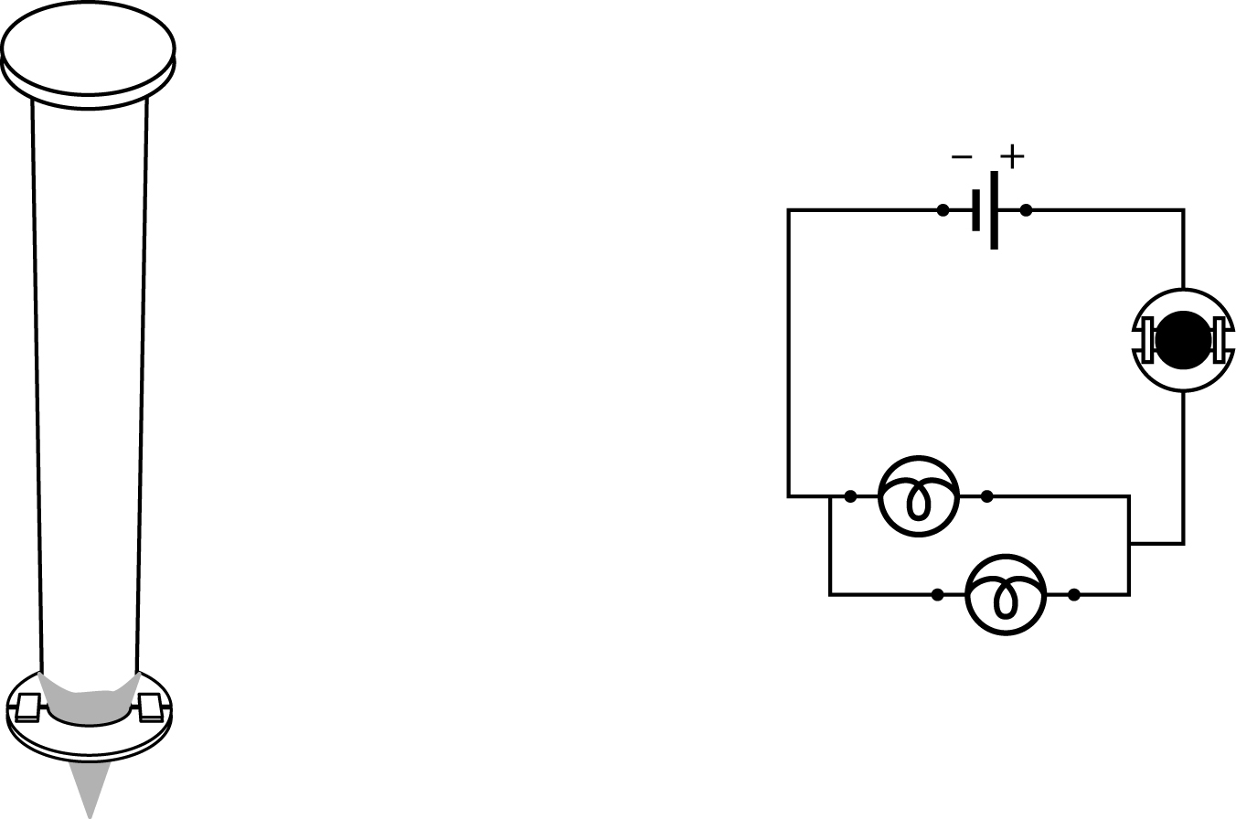
Maude brought the two diagrams below to help explain her approach.

Nail

Washer

a) Match each of the following components of the assembly with its electrical function. Explain your answers.
A. the plastic coating on the end of the nail

B. the washer and the nail
C. the wires
D. the light bulbs
E. the battery
b) Which electrical function did Maude not plan for in her system? What would you suggest she add to perform this forgotten function?
c) What type of current flows in Maude’s circuit? Explain your answer.
[ /7]
6. Answer the following questions on resistors.
EST

a) Write the value of each of the resistors below.
R1: R2:

Red Orange Yellow Gold Yellow Red Orange Gold

b) If subjected to the same voltage, which of these two resistors will allow more current to pass through it? Explain your answer.
[ /6]
7. In a company that manufactures resistors, a technician samples one out of every 1 000 for quality control. Using an accurate ohmmeter, he measures the resistance of each sample, and if the resistance is acceptable, production continues. If any reading is outside the acceptable limits, the production manager must be notified immediately.
EST

Suppose the technician obtains a reading of 210 750 Ω on the ohmmeter for a resistor whose value should be 23 × 10⁴ ±5% Ω. What will he do? Explain your answer.
[ /4]
8. Look at the diagrams below.
EST

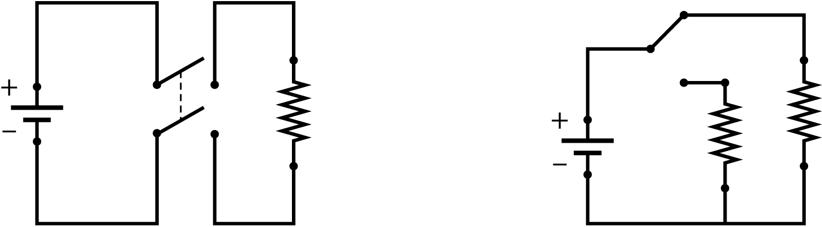
A B

What types of switches are represented in these diagrams? Explain your answers.
[ /4]
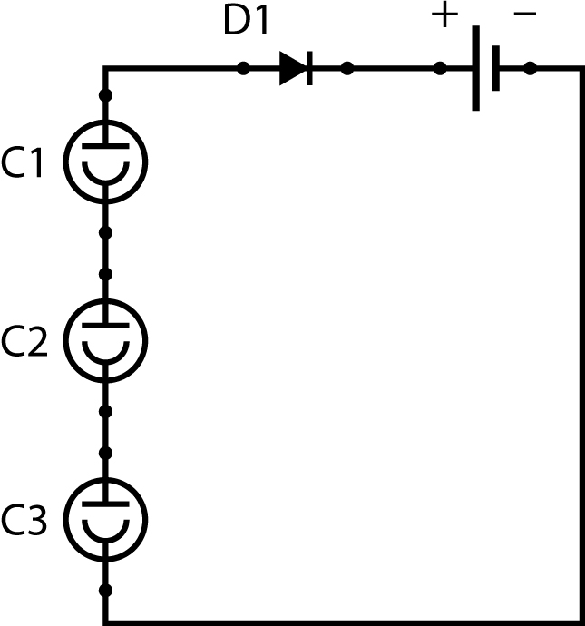
9. An increasing number of homes have solar lamps in their
flower beds, throwing a gentle light on the plants and grounds
at night. The lamps do not have to be plugged in. On close
examination, it becomes clear that they are actually a sort
of “battery charger.”
EST

The diagram opposite shows the “charger” part of a lamp,
which contains a nickel-cadmium battery.

a) What are the circuit elements C1, C2 and C3 called? What do they do?
b) When night falls, what does the element D1 do in this circuit?
c) How is electrical energy transformed during the day?
[ /5]
10. Safety illustrations often appear in the electrical circuits of devices we consider harmless, such as televisions and cameras.
EST

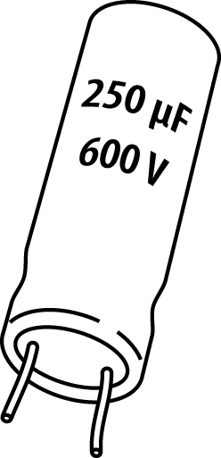
a) Name the electronic component illustrated opposite.
b) Why should we not touch the terminals of a capacitor?
Explain your answer.
[ /4]
[ /54]

