Mechanical engineering
CHAPTER 13

Concept evaluations by chapter

EST
1. When a house is under construction, builders often nail asphalt shingles to the roof.
a) Which components hold the shingles on the roof?
b) What is the mechanical function of these components?
[ /2]
2. Football is a sport that requires a lot of equipment, including a helmet. Inside the helmet is a layer of flexible padding to protect the player’s head. It is held in place with glue. What are the characteristics of the link between the padding and the helmet? Explain each characteristic.
a) Direct or indirect?
b) Rigid or flexible?
c) Removable or non-removable?
d) Complete or partial?
[ /8]
3. Helmets are mandatory not only in football; they are also required in ice hockey. One of the differences between football helmets and hockey helmets lies in their wire face masks. The masks on hockey helmets can usually be raised, but not the masks on football helmets.

a) Given that the mask is usually attached to the hockey helmet with two screws and two nuts, what are the characteristics of this link? Explain each characteristic.
A. Direct or indirect?
B. Rigid or flexible?
C. Removable or non-removable?
D. Complete or partial?
b) How many degrees of freedom does the mask have in relation to the helmet? Explain your answer.
EST
[ /10]
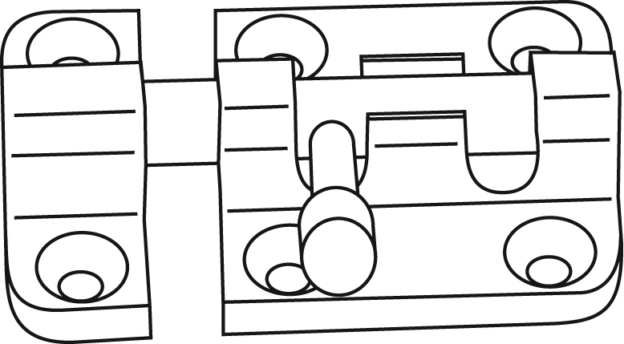
4. Safety bolts like the one illustrated below are used to lock doors.

Bolt Housing

a) What are the characteristics of the link between the bolt and the housing? Explain each characteristic.
A. Direct or indirect?
B. Rigid or flexible?
C. Removable or non-removable?
D. Complete or partial?
b) How many degrees of freedom does the bolt in this object have? Explain your answer.
EST
[ /10]
5. During a family breakfast, you explain that there are three main types of guiding. You use the jar of peanut butter with its screw-on lid, the cutlery drawer, the refrigerator door and the kitchen scissors as examples. Which type of guiding does each of these objects demonstrate?
a) jar of peanut butter
b) cutlery drawer
c) refrigerator door
d) kitchen scissors
[ /4]
6. During a car race, your know-it-all uncle comments continually on the adhesion of the tires to the track. For each remark, write whether it is true or false and identify the factor causing the strength of adhesion between the surfaces to vary.
EST
a) “They wasted a lot of money renovating this racetrack. As if covering it with asphalt instead of concrete would make any difference in the cars’ performances! It doesn’t change a thing!”
b) “Brrrr! It’s so cold! It’s a good thing it’s supposed to clear up and get warmer this afternoon. That will help the tires adhere to the track better.”
c) “Yesterday, I took my old Bonneville out on the track. It was losing a little oil. I hope there isn’t any left on the track surface because that could make the cars skid and cause an accident.”

d) “To think that they allowed an increase in the weight of the cars’ rear spoilers to prevent skidding. As if putting more weight on a tire makes it adhere better to the track! That makes no sense at all.”
e) “Why is that car starting the race with smooth tires? The track’s all wet from the rain. The mechanics should have put ribbed-tread wheels on the car to keep it from skidding.”
[ /10]
7. For a study on motion transmission, you have been asked to provide information on the main systems that perform this mechanical function. For each diagram below:
a) Name the motion transmission system.
b) Write “yes” or “no” regarding the possibility of reversibility.
c) Complete the diagram by indicating the direction of rotation of each of the driver and driven components in the system.
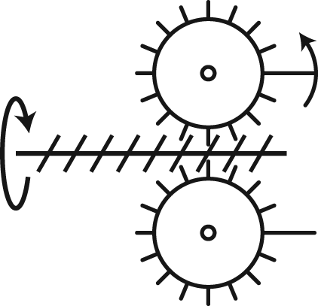
A
Name of the system:
Possibility of reversibility:

B
Name of the system:
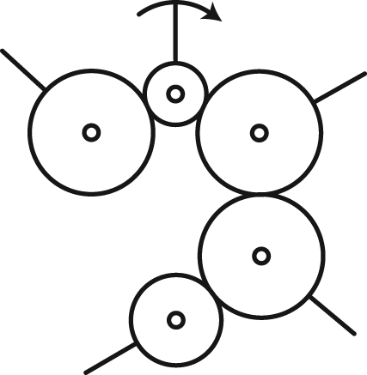
Possibility of reversibility:

C
Name of the system:
Possibility of reversibility:

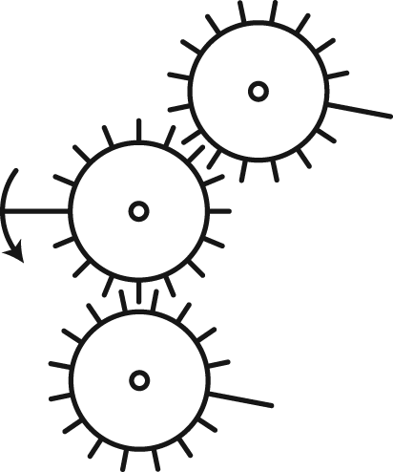

D
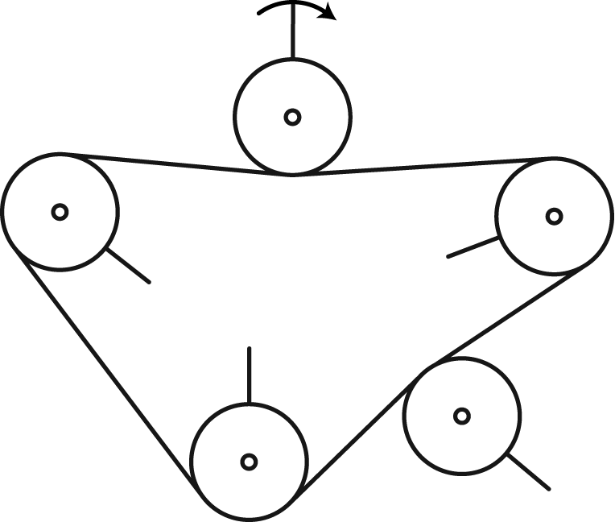
Name of the system:
Possibility of reversibility:

E
Name of the system:
Possibility of reversibility:

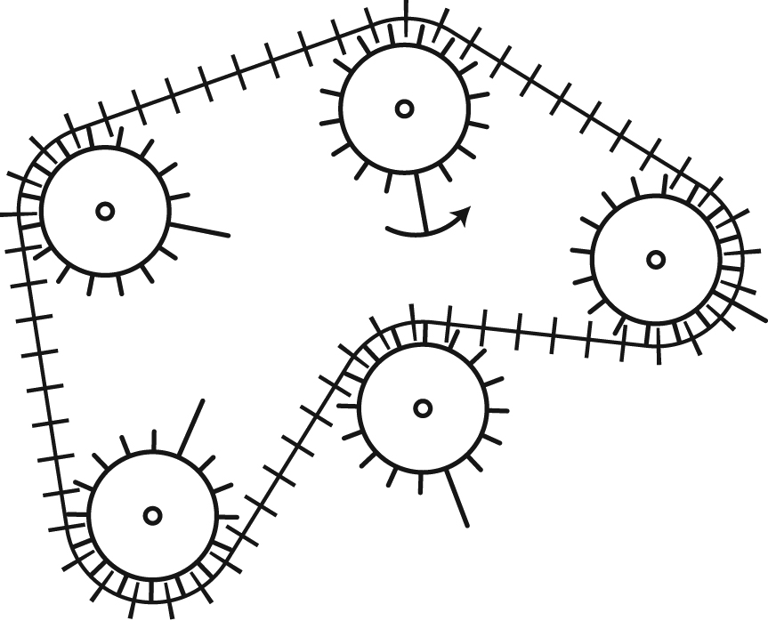

[ /20]
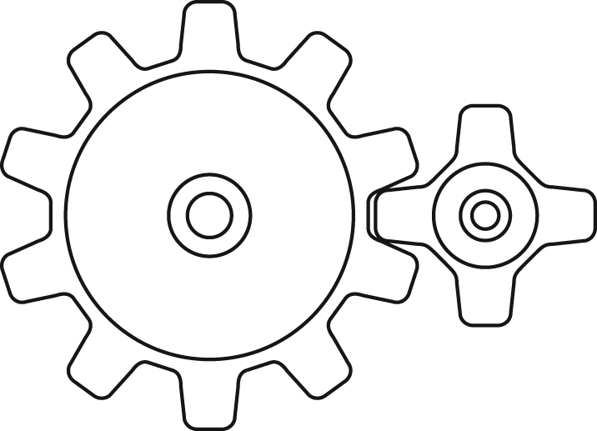
8. One characteristic an engineer may look for in the design of a technical object is a significant change in rotational speed between the parts. The two systems below have been proposed to meet this purpose.
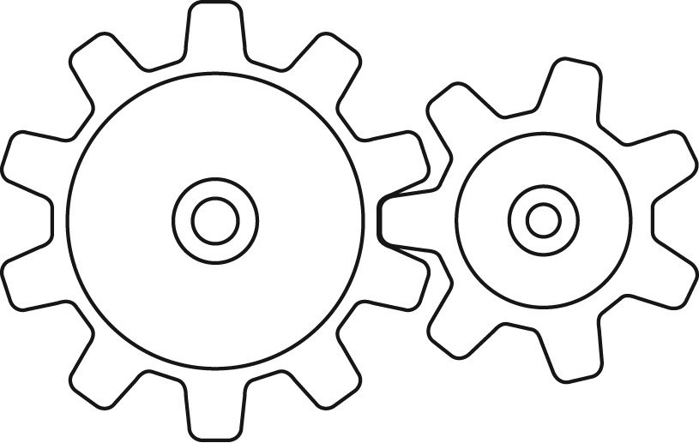
System 1 System 2

a) Which type of motion transmission systems are they?
b) In which system is the change in rotational speed between the gears greater? Explain your answer.
[ /4]
9. A company has lost its computer data on the rotational speed of the B components in the systems below. Using the information provided in the drawings of these systems, calculate the rotational speed of the B components.
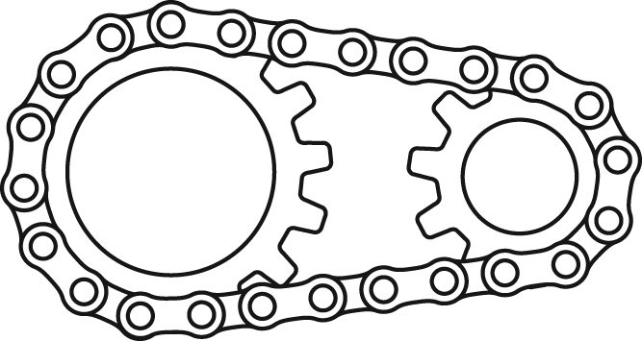

a) b)

B A A B
15 turns/minute 30 turns/minute


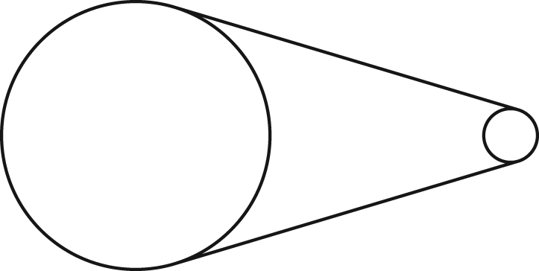
c) d)
Diameter
= 4 cm
A B A B
Diameter = 10 cm
Diameter = 20 cm Diameter = 20 cm
60 turns/minute 25 turns/minute

[ /8]
10. You are presented with the drawing
opposite for the design of a small vehicle
operating on a spark-ignition engine.
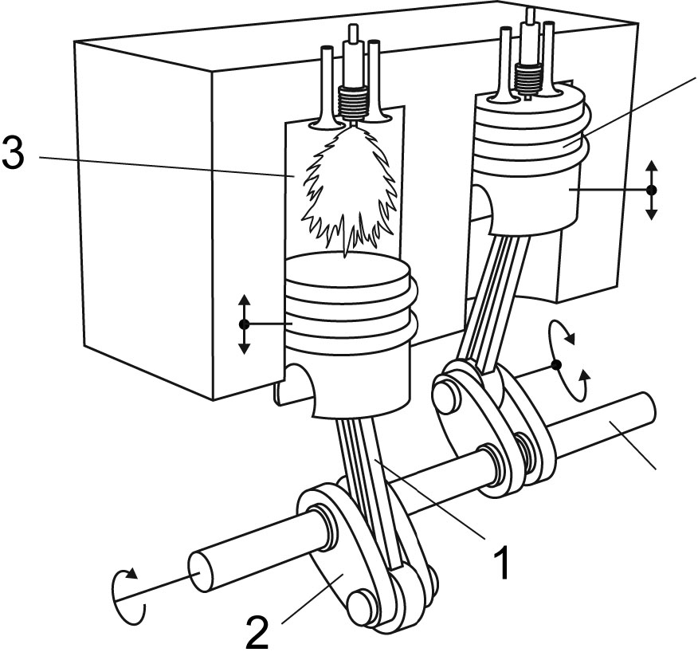
Piston

Crankshaft

a) Does this drawing represent a motion
transmission or a motion transformation
system? Explain your answer.

b) What is the name of this type of system?
c) Name each of the numbered parts.
1:
2:
3:
d) What does part 3 do?
[ /9]
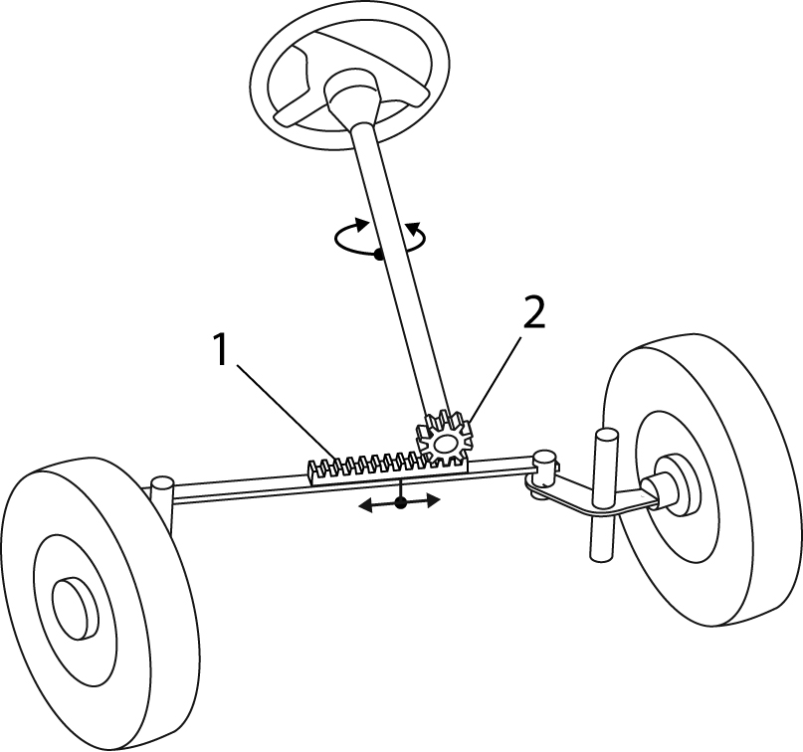
11. Later during the same vehicle design process, you are presented with the steering system illustrated below.

a) Does this drawing represent a motion
transmission or a motion transformation
system? Explain your answer.
b) What is the name of this type of system?
c) Name each of the numbered parts.
1:
2:
[ /5]
[ /90]

