Manufacturing technical objects

ANsWER KEY

Checkups and follow-ups
EST
Questions 1–7, 9, 11, 14, A, B and D
ChaptEr 12
Checkup
1 MATERIALS (pp. 386–390)
1. Depending on how they are used, technical objects are likely to be subjected to stress. Name the constraint at work in the part of the object indicated in the photos below.
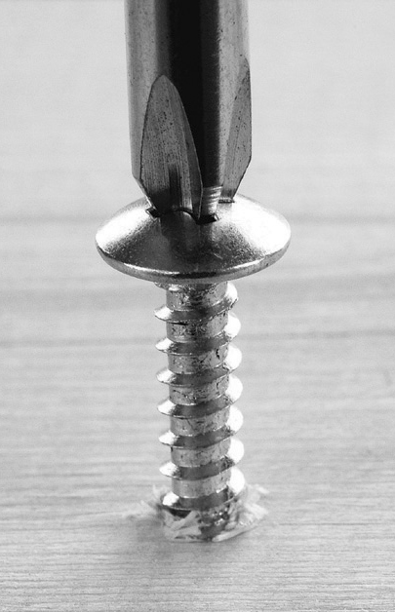
A
B
C
Tension |  | Compression |  | Torsion
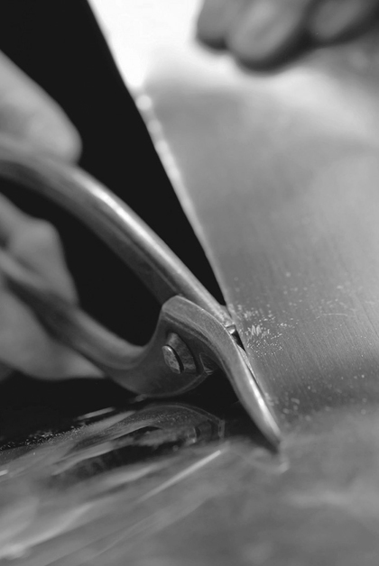
D
E
Deflection |  | Shearing
2. When manufacturing a technical object, it is often necessary to define the mechanical properties of different materials in order to make the most suitable choice. Which mechanical property is sought in each of the following examples?

a) a plastic that keeps its shape even when twisted
Stiffness
b) wooden flooring that resists indentation by pointed objects, such as shoe heels
Hardness
c) a metal that stretches well to make wire
Ductility
d) a boat hull that resists shocks caused by running into shoals
Resilience
e) a material that bends easily, without breaking, to make eavestroughing
Malleability
2 CATEGORIES OF MATERIALS AND THEIR PROPERTIES (pp. 390–401)
3. Identify the category of material used to make the following objects. Choose from the following categories (each category may be used only once):
– wood and modified wood – metals and alloys
– plastics – ceramics
– composites
a) coins | Metals and alloys
b) a sheet of plywood | Wood and modified wood
c) a pane of glass | Ceramics
d) a soft-drink bottle | Plastics
e) a bulletproof vest | Composites
4. Which category of material would you suggest to meet the following needs? Choose from the same categories as in question 3 (each category may be used only once).
a) a shiny material that conducts electricity well
Metals and alloys
b) a light, durable and inexpensive material
Plastics
c) a material that combines the properties of several categories of materials
Composites
d) a natural-looking material, with variations in colour and shade, that can be shaped and assembled easily
Wood and modified wood
e) a durable material with low electrical conductivity and high degrees of heat resistance and hardness
Ceramics
5. During an experiment, a student puts two iron nails in a beaker containing an aqueous solution. One of the two nails was previously coated in grease. Which of the two nails will take longer to rust? Explain your answer.
The nail covered in grease will take longer to rust because grease is a coating that protects materials from degradation.
6. In the Middle Ages, when knights had swords forged, the steel blades were heated then dipped in water.
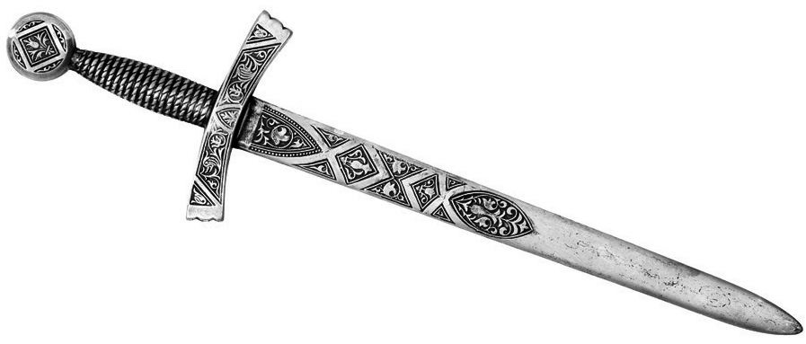
Name the thermal treatment just described and identify the main advantage of the treatment for the eventual properties of the blade.
The treatment described is quench hardening, which increases the hardness of the blade.
3 Technical Drafting (pp. 401–410)
7. Look at the two drawings below of a compact disk storage tower.
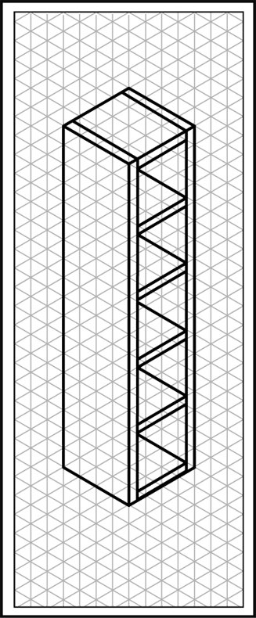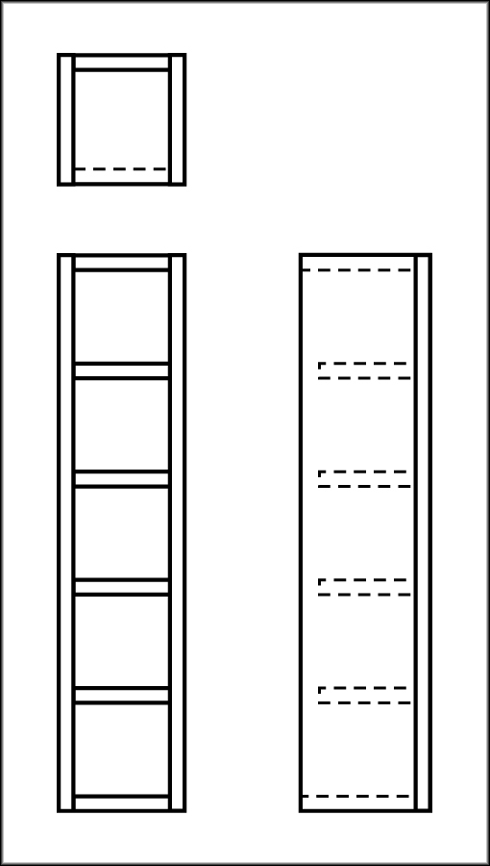
a) Name the type of projection used in each drawing.
B
A
Drawing A is an isometric projection, and
drawing B is a multiview projection.
b) Could these two drawings be called general arrangements? Explain your answer.
Yes, because they both represent the
overall appearance of the object.

⇒ Question 8 is not intended for students in the EST program.
9. To manufacture a part, a student relies on the drawing opposite.
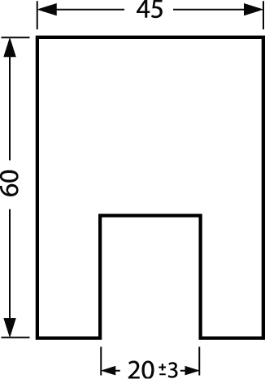
a) When the actual part dimensions are checked, the width of the indentation is found to measure 22 mm. Does this part comply with the drawing? Explain your answer.
The part complies with the drawing because the actual width is within the acceptable margin of error indicated by the tolerance. Since the tolerance is 3 mm, the indentation may be as wide as 23 mm.
b) What is the minimum width the indentation could have?
17 mm

⇒ Question 10 is not intended for students in the EST program.
4 MANUFACTURING: TOOLS AND TECHNIQUES (pp. 410–417)
11. Drilling is one of the most frequently used techniques in the manufacture of technical objects.
a) What is the purpose of drilling?
To make holes in a material
b) What are the two main factors to consider when choosing a drill bit?
The diameter of the hole to be drilled and the type of material
c) Must the two factors in question b) also be considered when determining the speed of rotation of the drill bit? If not, what should be considered instead?
The same two factors should be considered.

⇒ Questions 12 and 13 are not intended for students in the EST program.
14. For which assembly technique is each of the following tools most often used?
a) a hammer | Nailing
b) carpenter’s glue | Bonding
c) a soldering iron | Welding
d) a screw | Screwing
REVIEW QUESTIONS
⇒ Question C is not intended for students in the EST program.
A. The photo opposite shows a handsaw, a tool often used to saw wood. The cutting part of this tool is made out of steel, while the handle is made of acrylonitrile butadiene styrene (ABS).
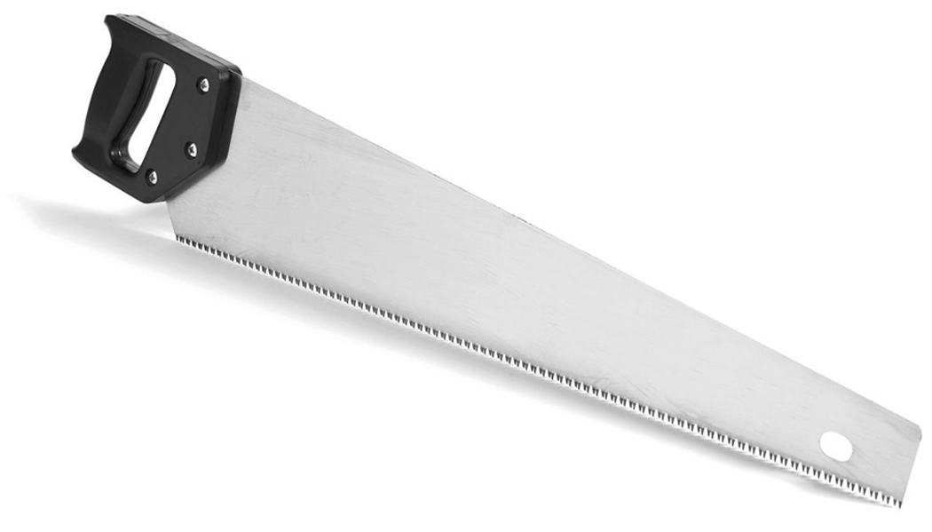
a) Which category of material does the cutting part belong to?
Metals and alloys
b) Since ABS can be remoulded when heated, which subcategory of plastics does this material belong to?
Thermoplastics
c) When the saw is used, the blade sometimes bends and then returns to its original shape. Which constraint is this part being subjected to and which mechanical property allows it to return to its original shape?
The blade is undergoing deflection, and the mechanical property that allows it to return to its original shape is its elasticity.
d) One of the important features of the handle is that it is difficult to deform permanently. Which mechanical property does the handle exhibit?
Rigidity
B. The steel used to manufacture the blade of the saw in question A has been quenched. What was the purpose of this treatment?
Quenching increases the hardness of the blade, which improves its sawing effectiveness.
D. Prepare your own summary of Chapter 12 by building a concept map.
See the Concept maps section in Guide B.
Follow-up
1. If you were planning to buy some wooden boards, how could you make sure that the lumber you choose was harvested according to sustainable development practices?
By checking to see whether the lumber had received certification to that effect, such as FSC certification.
2. Paper is one of the main products derived from logging. Suggest several ways in which we could limit our paper consumption.
Answers will vary. Examples: by recycling paper and by using recycled paper
– by printing only the pages I need from the computer
– by using both sides of a sheet of paper
– by buying only the magazines and newspapers that I really want to read.

