Carbon Cycle

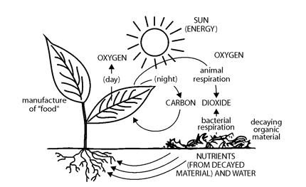

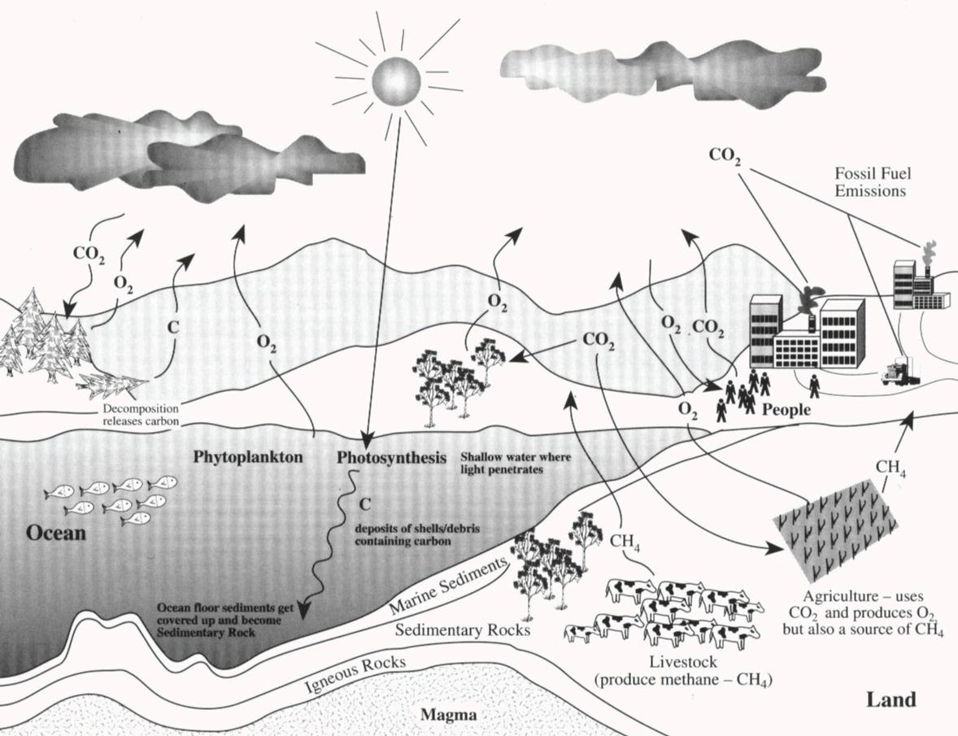
Fill in the following – it is 2018 – Google it, if necessary!

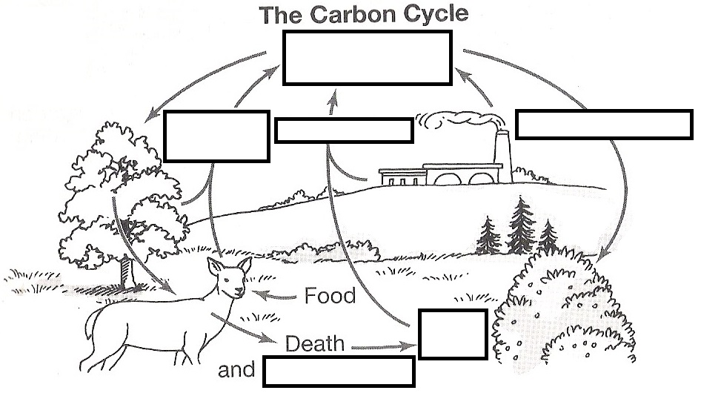

Photosynthesis BCE

_____________________________________________________________________________________

Cellular Respiration BCE

_____________________________________________________________________________________

How are we disrupting the Carbon cycle?

What is the result of this disruption?

