Bond Energies
https://chem.libretexts.org/Textbook_Maps/Physical_and_Theoretical_Chemistry_Textbook_Maps/Supplemental_Modules_(Physical_and_Theoretical_Chemistry)/Chemical_Bonding/Fundamentals_of_Chemical_Bonding/Bond_Energies
Atoms bond together to form compounds because in doing so they attain lower energies than they possess as individual atoms.

A quantity of energy, equal to the difference between the energies of the bonded atoms and the energies of the separated atoms, is released, usually as heat energy.

That is, the bonded atoms have a lower energy than the individual atoms do.

When atoms combine to make a compound, energy is always given off, and the compound has a lower overall energy.

When a chemical reaction occurs, molecular bonds are ________________________ and
other bonds are _________________________ to make different molecules.

When a chemical reaction occurs, the atoms in the reactants ___________________________
their chemical bonds to make products.

All reactions require the addition of energy to start.

What determines whether the reaction is overall endothermic or overall exothermic is the
difference between ____________________________________________________________
____________________________________________________________________________

The new arrangement of bonds does not have the same total energy as the bonds in the reactants.

Therefore, when chemical reactions occur, there will always be an accompanying energy change.
e.g. The bonds of hydrogen and oxygen are broken to form the bonds of the water molecules.
2 H2(g) + O2(g) → 2 H2O(ℓ)

Energy is always required to break a bond, which is known as bond energy. Energy is
necessary to _________________________________________________________________.

Energy is released when a bond is formed. Energy is released as _______________________
____________________________________________________________________________.

When a bond is strong, there is a higher bond energy because it takes more energy to break a strong bond.

The shorter the bond length means a greater the Bond Energy because of increased electric attraction.

Recall Coulomb's Law:

In general, the shorter the bond length, the greater the bond energy.

Double bonds are higher energy bonds in comparison to a single bond (but not necessarily 2-fold higher).

Triple bonds are even higher energy bonds than double and single bonds (but not necessarily 3-fold higher).

Exothermic and Endothermic Reactions

Endothermic reactions require energy, so energy is a reactant.

N2(g) + O2(g) + 72 kJ → 2 NO(g)

Exothermic reactions releases energy, so energy is a product.

2 H2(g) + O2(g) → 2 H2O(ℓ) + 572 kJ

Graphically:
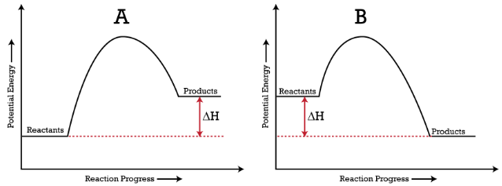
∆H
Enthalpy H
- is the total energy content of a system

- is the sum of the kinetic and potential energies of a system

- cannot be measured but the change in enthalpy ∆H can

- measured in kJ/mole

∆H can be calculated in many ways--using Bond Energies is one way.

Using Bond Energies to Calculate ∆H
Combustion reactions are ____________________________ i.e. they release more energy
when the product bonds form than the energy absorbed when the reactant bonds are broken.
1. Write the BCE for the combustion reaction of BBQ propane:

______________________________________________________________________

2. Draw the Lewis Dot Diagrams of the Particles in a VERY organized fashion in columns:

REACTANTS | PRODUCTS

3. Do the Math in a VERY organized fashion immediately under the moles of particles:

4. Subtract the Sum of the Bond Energies of the Products from the Sum of the Bond Energies of the Reactants:

"BER minus BEP"

5. The molar enthalpy (ΔH) for the combustion of ethane is _____________________.

