Visible Thinking
Ba(OH)₂(s) + NH₄SCN(s) → ______________________________________________

Labeled Sketch of Initial Set Up

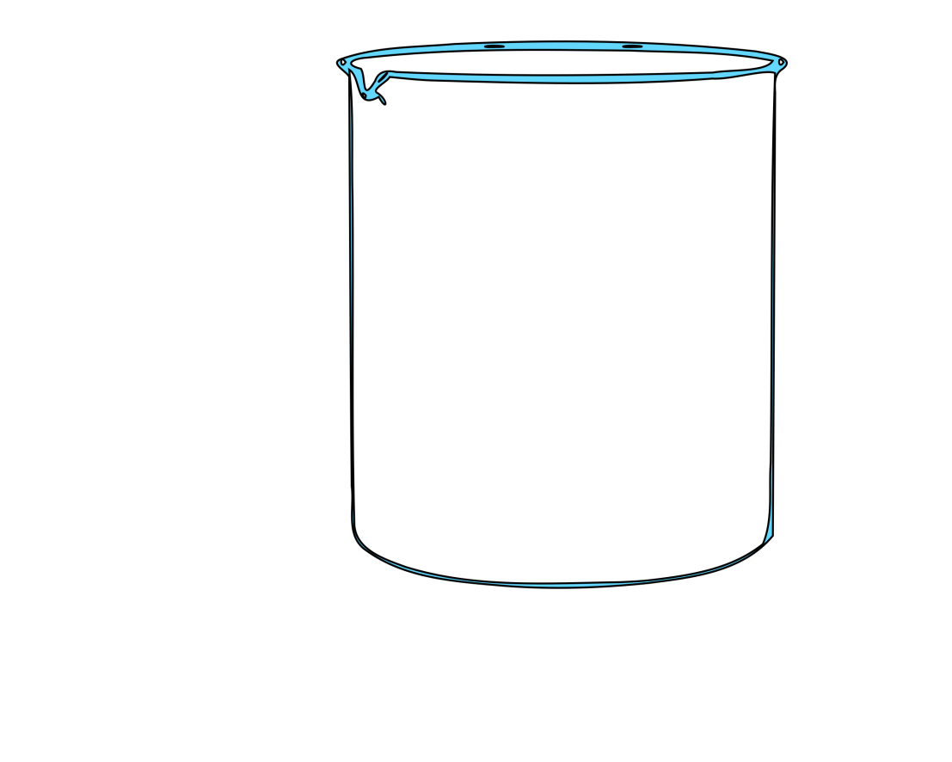
Observation/Test | What you observed | What that means
Colour and State of all Original Chemicals

Odour after

Temperature before and after

Litmus Paper

Colour and State of Final Chemicals

Labeled Sketch of Results:

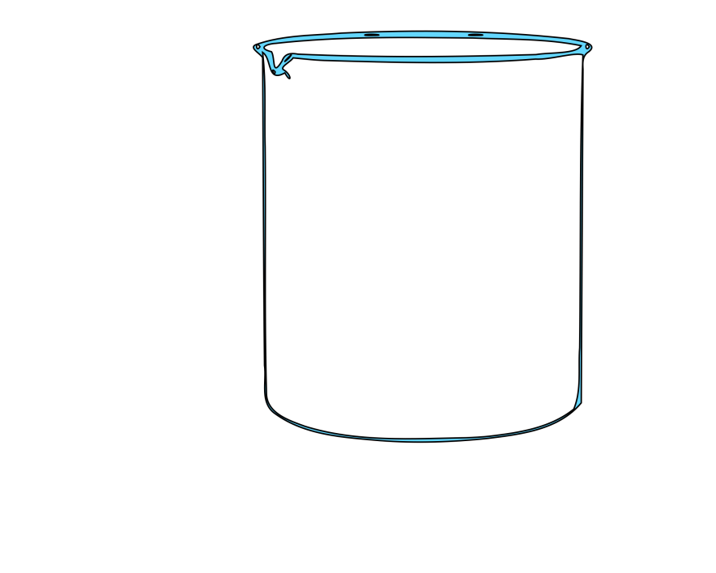

Thermo-chemical equation for what is happening inside the beaker:

____________________________________________________________________________

Thermo-chemical equation for what is happening outside the beaker:

____________________________________________________________________________

2 sentences as to how the above 2 events happened:

____________________________________________________________________________

____________________________________________________________________________

