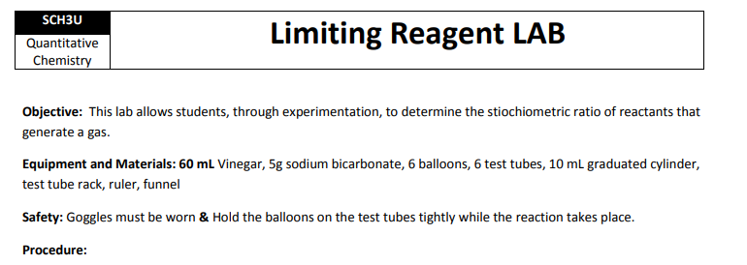
1.
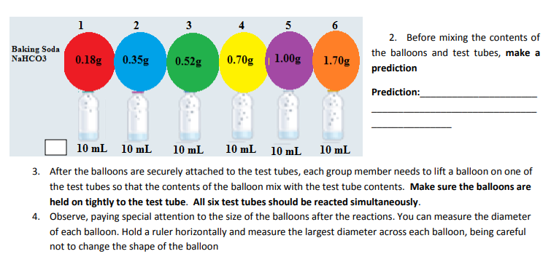
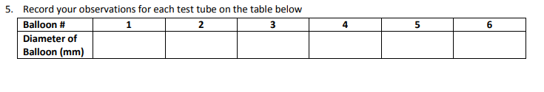
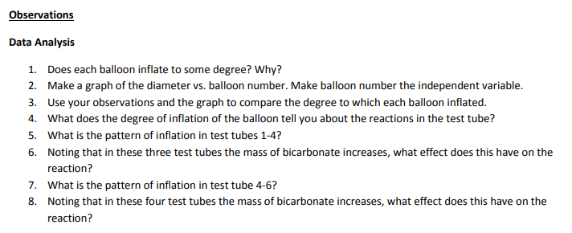

A) Write the BCE for the reaction that took place:

_____________________________________________________________________________________

B) Write the N.I.E. for the above reaction:

_____________________________________________________________________________________
