Populations and communities

ANsWER KEY

Checkups and follow-ups
EST
Questions 1–19 and A–C
ChaptEr 9
Checkup
1 STUDYING populations (pp. 292–302)
1. What do the living organisms that form a population have in common?
They are of the same species, and they live in a shared space.
2. Give two examples of a plant population and two examples of an animal population.
Answers will vary. Example: the water lilies in Lac Bleu and the daisies on Île aux Coudres; the grey squirrels on Mont Royal and the moose in Réserve faunique Mastigouche.
3. How can knowing the size of a wolf population be useful?
Answers will vary. Example: It can tell us whether the population is healthy or in decline, which will affect other species in the same environment.
4. For each of the following examples, name the factor that makes the population size vary (births, deaths, immigration or emigration) and specify its effect.
a) Every spring, Canada geese return to the shores of Lac Tranquille.
b) During a logging operation, the noise from the forestry vehicles scared away the white-tailed deer in the vicinity.
c) In the spring, a female bear nurses her three cubs in her den.
d) Fish farmers stock a river with salmon fry.
e) Cottage owners can eliminate voles by installing traps in the roof.
Write your answers in the table below.
Example | Factor | Effect on population size
a) | Immigration | Increase
b) | Emigration | Decrease
c) | Birth | Increase
d) | Immigration | Increase
e) | Death | Decrease
5. What happens to a population when death and emigration rates are higher than birth and immigration rates?
The size of the population decreases.
6. The photos below show a slug (A), an American robin (B) and a bison (C). What would be the most appropriate method for measuring the size of a population of each of these species?
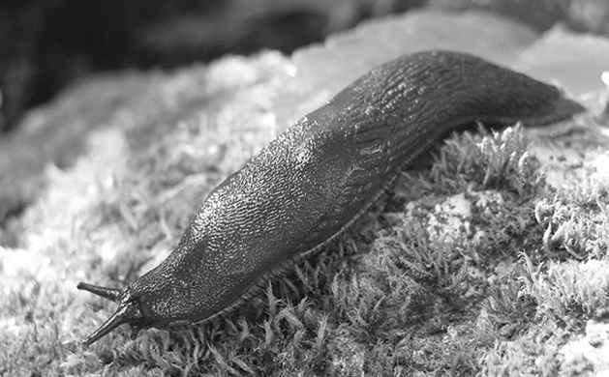
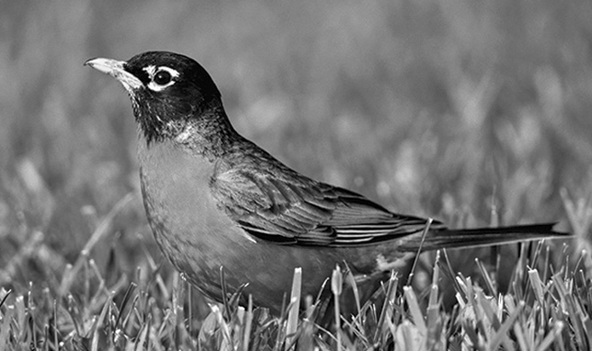
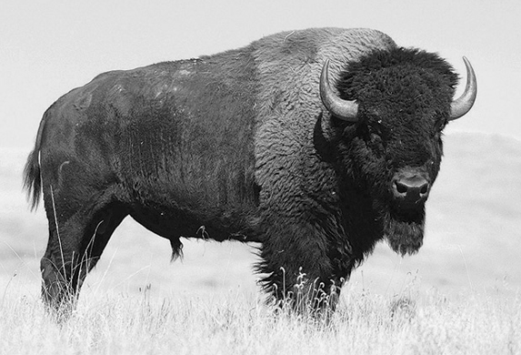
A. Counting by sample area. B. Mark and recapture. C. Counting by individuals.
7. Scientists want to determine the size of a population of brook trout in a lake. First, they catch 50 trout, tag them and release them. A few days later, they catch 55 trout, including 11 tagged fish.
a) Which method for measuring population size did the scientists use?
Mark and recapture.
b) What is the estimated population of brook trout in this lake? Show your calculations.
Population size =
Number of marked fish × Total number of fish captured the second time
Number of marked fish recaptured

Population size = = 250 individuals
50 × 55
11

8. The twelve-spotted lady beetle feeds on the eggs of the Colorado potato beetle (a pest that attacks potato plants).
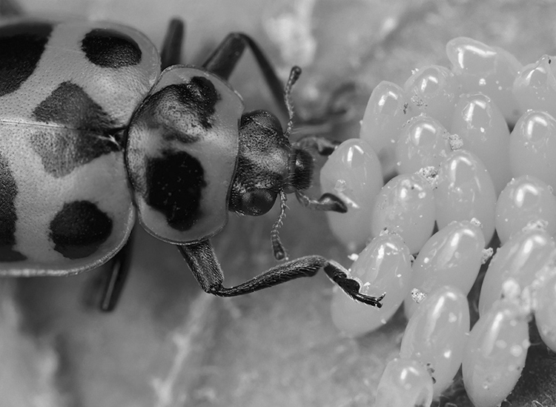
Biologists wanted to study the population of this type of lady beetle in a potato field of 10 000 m², so they counted the number of individuals in one-square-metre quadrats. The table on the following page presents the results of this sampling.

Quadrat number | Number of twelve-spotted lady beetles | Quadrat number | Number of twelve-spotted lady beetles
1 | 2 | 6 | 0
2 | 1 | 7 | 0
3 | 0 | 8 | 1
4 | 1 | 9 | 1
5 | 0 | 10 | 0
a) What is the size of the population of twelve-spotted lady beetles in the field under study? Show your calculations.
Population size =
Average number of individuals per section × Total study area
Area of a section

2+1+0+1+0+0+0+1+1+0
10

Number of individuals
Space occupied

6 000
10 000

Average number of individuals per section = = 0.6 individuals
per section
0.6 × 10 000
1

Population size = = 6 000 individuals

b) What is the population density of twelve-spotted lady beetles in the field under study? Show your calculations.
Population density =
Population density = = 0.6 individuals per m²

c) If the population of twelve-spotted lady beetles were higher than the Colorado potato beetle population, what would happen?
The size of the Colorado potato beetle population would decrease, but eventually so would the lady beetle population, from lack of food.
9. The table below contains statistics on the human population and the area of Canadian provinces and territories (according to Statistics Canada, April 1, 2007).
Province or territory | Population | Total area  (km²) | Population density  (per km²)
Nfld. | 506 548 | 405 212 | 1.3
P.E.I. | 138 800 | 5 660 | 24.5
N.S. | 932 966 | 55 284 | 16.9
N.B. | 748 878 | 72 908 | 10.3
Québec | 7 687 068 | 1 542 056 | 5.0
Ontario | 12 753 702 | 1 076 395 | 11.8
Manitoba | 1 182 921 | 647 797 | 1.8
Saskatchewan | 990 212 | 651 036 | 1.5
Alberta | 3 455 062 | 661 848 | 5.2
B.C. | 4 352 798 | 944 735 | 4.6
Yukon | 30 883 | 482 443 | 0.06
N.W.T. | 41 795 | 1 346 106 | 0.03
Nunavut | 31 216 | 2 093 190 | 0.01
a) In which province or territory is the population density the lowest?
Nunavut.
b) In which province or territory is the population density the highest?
Prince Edward Island.
c) How does Québec rank in population density compared to the other provinces and territories?
It ranks sixth.
10. a) What is the main factor affecting the density of any population?
Access to food and water.
b) Name two other factors that have an impact on population density.
Answers will vary. Examples: climate, the presence of predators, parasites or disease, and disasters of natural or human origin.
11. Given that most of the Canadian population lives in cities, what is the pattern of population distribution in our country?
Clumped distribution.
12. Which pattern of distribution is illustrated by each of the following situations?
a) In a forest, the fir trees are scattered about at random.
Random distribution.
b) Fungi grow in colonies on the trunks of dead trees.
Clumped distribution.
c) Several clouds of mayflies hover over a lake.
Clumped distribution.
d) The hummingbirds in a valley aggressively defend their respective territories; they tend
to build their nests at equal distances from one another.
at equal distances from one another.
Uniform distribution.
13. Do the studies described below relate to a biotic or an abiotic factor?
a) An ecologist studies the effect of hares’ browsing on a  population of fir trees. | Biotic factor.
b) Chemists test the acidity of a soil sample. | Abiotic factor.
c) A water specialist assesses the amount of sunlight at  different depths in a lake. | Abiotic factor.
d) Ecologists test a river for amounts of phosphorus from  agricultural fertilizers. | Biotic factor.
14. Is the amount of oxygen in a lake a limiting factor for a population of fish (bass or trout, for example)? Explain your answer.
Yes, the amount of oxygen in a lake is a limiting factor for a population of fish. Explanations will vary. Example: If the amount of oxygen in a lake decreases, there will be fewer fish, or they will disappear altogether.
15. Why does the size of the hare population in Québec decrease when the size of the lynx population increases?
The lynx preys on the hare. If the number of lynx increases, they will hunt more hares, which will reduce the size of the hare population.
2 STUDYING communITIEs (pp. 303–309)
16. The Earth is home to many communities.
a) What do the living organisms that form a community have in common?
They share the same habitat.
b) What is a community composed of?
A community is composed of populations of different species.
17. The Amazon Rainforest, in South America, is considered the most diverse forest habitat on Earth. What criteria do scientists use to establish the degree of biodiversity in a community?
They study the numbers of species in the community, namely, its species richness. They also study the relative abundance of each species in the community.

18. Look at the photo opposite and answer the following questions.
a) What is the interaction between the bee and the flower called?
Mutualism (or predation).
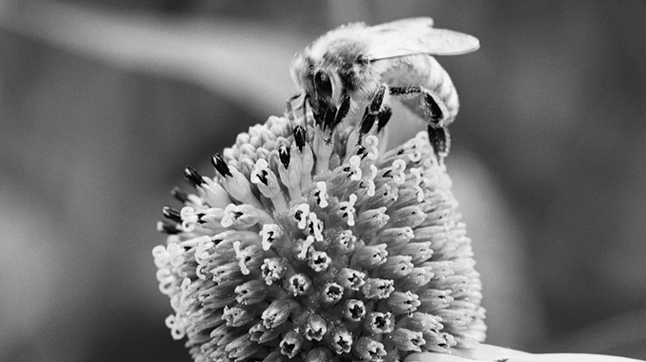
b) If a bumblebee flies up to the flower to feed on its
nectar, how will the first bee and the bumblebee interact?
Through interspecific competition.
c) If a bird eats the bee, what type of interaction would that be?
Predation.
d) If aphids attack the flower and damage its leaves, what would be the interaction between the aphids and the flower?
Parasitism.
e) If a spider spins a web, attaching one of its threads to the flower stem, what would be the interaction between the spider and the flower?
Commensalism.
19. True or false? Explain your answers.
a) The biodiversity of a community can be qualified as high when one species in the community is much more abundant than other species.
False. The relative abundance of the different species must be similar.
b) In a relationship of parasitism, one of the living organisms is a parasite, and the other is its prey.
False. One is the parasite and the other, the host.
c) When populations in a community interact through mutualism, this interaction tends to increase their population densities.
True. Both populations benefit from this interaction.
d) Competition has a positive impact on population density.
False. On the contrary, competition reduces population density.
e) Parasitism and predation refer to exactly the same phenomenon.
False. In parasitism, the parasite lives inside its host or on its surface.

REVIEW QUESTIONS
A. The mark-recapture method was used to estimate the size of the groundhog population in a field. According to this estimate, the population was 50.
a) Subsequent studies of groundhog behaviour revealed that these animals can recognize a trap more easily if they have already been captured. In light of this new information, is the estimate of the size of the groundhog population too high or too low? Explain your answer.
The estimate of the population size is too high. Since a groundhog that has already been trapped is less likely to be trapped again than one that has never been caught, the denominator of the equation to estimate the population size (number of marked animals recaptured) is smaller than it should really be. As a result, the population size is overestimated.
b) Recapturing took place in May, when it was observed that many females were about to give birth. In light of this information, is the groundhog population more likely to grow or decrease?
The groundhog population is more likely to grow because of the births.
c) Explain why quadrat sampling would not have been appropriate for estimating the size of the groundhog population.
Quadrat sampling would not have been appropriate because groundhogs are animals that move about quickly, especially in the presence of humans.
B. During a study on a population of red fox, many of these animals are discovered to live near the groundhog population of the previous question.
a) Since foxes may feed on groundhogs, what type of interaction connects these two populations?
Predation.
b) Do the fox and groundhog populations form a community? Explain your answer.
Yes, they form a community because they are two populations of different species sharing the same habitat.
c) How does the presence of foxes affect the density of the groundhog population?
The presence of foxes tends to reduce the groundhog population density.
d) Explain why the size of the fox population could not be calculated using aerial photography and suggest an appropriate method for estimating the population size.
The use of aerial photography would not be appropriate because foxes often live under cover of trees and tall grass, making it difficult to spot them on photographs. The most appropriate method for estimating the population size would be mark and recapture, as for the groundhogs.
C. Prepare your own summary of Chapter 9 by building a concept map.
See the Concept maps section in Guide B.
Follow-up
1. Do you think that the methods used to save peregrine falcons could be applied to all other endangered species?
Answers will vary. Example: No, some species could be difficult to raise in captivity.
2. Peregrine falcons feed on other birds, especially pigeons. These birds of prey are now introduced into airports. Explain how they can be useful in such places.
Peregrine falcons living close to airports control populations of birds that may collide with airplanes and cause accidents or mechanical breakdowns.

