Answer Key Quiz September 21st 2017

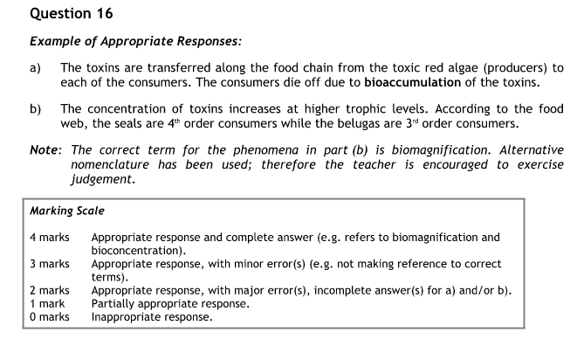
Question 5
B

Question 3

Trend
- Most students prefer visits with friends (the mode)
Variables:
Independent
- Students’ favorite after-school activities
Dependent
- Number of students
Controlled Variables (if you could)
- Sex of students
- Age of students
- Ethnicity of students
- Time of year asked
- Etc ???
Martian Car Question Be able to defend your picks!

Characteristics of Life
- Living organisms have a definite organisation consisting of structural and functional units called cells that make the physical basis of life namely protoplasm.
- Living organisms obtain simple molecules from their surrounding environment, convert them into complex protoplasmic constituents thereby increasing in size and complexity. This phenomenon is called intrasusception (internal growth).
- Living organisms are capable of utilising, transferring or transforming energy to carry on various life processes.
- Living organisms have the capacity to produce young ones of their kind. This property is called reproduction.
- Living organisms show a complex array of biochemical processes, collectively known as metabolism. These activities may be synthetic in nature involving the formation of an organic compound (anabolism) or of destructive nature, involving the breakdown of an organic compound (catabolism).
- Living organisms exhibit various mechanisms for maintaining a constant state.
- Living organisms show adaptations to their surrounding environment.
- Living organisms show the ability to undergo evolution over a period of time.
- Living organisms exhibit the capacity to respond to a stimulus. This property is called as irritability.
- Living organisms are modified in such a way as to perfectly adapt themselves to the environment in which they live.

