Animal Cell Colouring
Colour code:
Cell Membrane | Brown | Nucleus | Yellow | DNA | Black
Cytosol | Pink | Golgi Apparatus | Light Brown | Endoplasmic Reticulum | Orange
Ribosomes | Purple | Lysosomes | Grey | Nuclear Membrane | Red
Mitochondria | Dark Blue

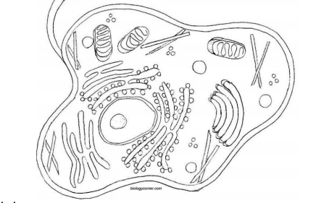

Plant Cell Colouring
Colour code:
Cell Wall | Brown | Nucleus | Yellow | DNA | Black
Cytosol | Pink | Golgi Apparatus | Light Brown | Rough Endoplasmic Reticulum | Orange
Ribosomes | Purple | Lysosomes | Grey | Nuclear Membrane | Red
Mitochondria | Dark Blue | Chloroplast | Dark Green | Food Vacuole | Light Blue

