Bonding, Electronegativity and Lewis Structures

1. When electrons are shared unequally, chemists characterize these types of bonds as _________.

a. polar covalent b .ionic c. pure covalent d. nonpolar covalent e. none of these

2. Atoms with greatly differing electronegativity values are expected to form

a. no bonds b. polar covalent bonds c. nonpolar covalent bonds d. triple bonds e.ionic bonds

3. Nonmetal elements typically have ______________ electronegativities.

a. low b. high c. neutral d. strong e none of these

4. The electron pair in a 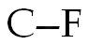 bond could be considered

a. closer to C; carbon has a larger radius and thus exerts greater control over the shared electron pair
b. closer to F because fluorine has a higher electronegativity than carbon
c. closer to C because carbon has a lower electronegativity than fluorine

d. an inadequate model because the bond is ionic

e. centrally located directly between the C and F

5. What is the correct order of the following bonds in terms of decreasing polarity?

a. 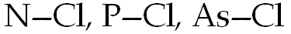 b 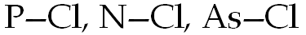 c d.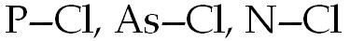 e.

6. Which of the following bonds would be the most polar without being considered ionic?

a. 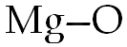 b. 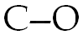 c. 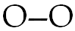 d. 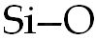 e. 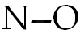

7. Which of the following bonds would be the least polar yet still be considered polar covalent?

a. b. c. d. e.

8. An 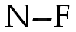 bond is expected to be more polar than an 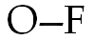 bond. a. True b. False

9. Carbon dioxide has ______________ bonds.

a. ionic b covalent c. polar covalent d. magnetic e. none of these

10. Which of the following compounds contains an ionic bond?

a. HCl(g) b. NaCl c. CCl4 d. SO2 e. O2

11. Which of the following compounds contains one or more covalent bonds?

a. NaCl b. CaO c. CO2 d. Cs2O e. BaBr2

12. The most electronegative element is: a. He b. F c. At d. Cs e. O

13. In the hydrochloric acid molecule, the atoms are held together by a(n)

a. ionic bond b. polar covalent bond c. nonpolar bond d. double bond e.none of these

14. Which of these is not an ionic compound? a.K2CO3 b. HCl c NaSCN d NH4I e MgCl2

****Either b or d******
15. Which of the following elements has the lowest electronegativity?

a. Rb b. Na c. Ca d. S e. Cl

16. When a molecule has a center of + charge and a center of - charge, it is said to have a _______.

a. magnetic attraction b. diatomic bond c. double bond d. polyatomic ion e. dipole moment

17. Which of the following has the most nonpolar bond?

a. H2S b. HCl c. Br2 d. OF2 e. all are nonpolar.

18. Which diagram best represents a polar molecule? (an ionic bond is an extreme polar bond)
+
-
1) Cl₂ 2) H₂ 3) HCl 4) NaCl
a. 1
b. 2
c. 3
d. 4

19. The electrons in a bond between two iodine atoms (I₂) are shared

a. Equally, and the resulting bond is polar. b. Equally, and the resulting bond is nonpolar.

c. Unequally, and the resulting bond is polar. d. Unequally, and the resulting bond is nonpolar.

20. As a calcium atom undergoes oxidation to Ca⁺² the overall size of the atom

a. Increase b. Decrease c. Remain the same

21. A neutral atom changes to an ion with a charge of +3 by

a. gaining 3 protons b. losing 3 protons c. gaining 3 electron d. losing 3 electrons

22. How many of the following will have Lewis structures with multiple bonds? CO, CO2, CO3^{2}, N2, O2

a. 1 b. 2 c. 3 d. 4 e. 5

23. Which of the following has the most nonpolar covalent bond?

a. N2 b. CO c. HI d. CCl4 e. NaCl

24. Which of the following has a triple bond?

a. CH4 b. CO c. SO2 d. NO3 e. none of these

25. Which of the following has primarily ionic bonding?

a. N2O3 b. Na2O c. CO2 d. CCl4 e. none of these

26. The number of polar covalent bonds in NH3 is

a. 1 b. 2 c. 3 d. 4 e. none of these

27. If atom X forms a diatomic molecule with itself, the bond is

a. ionic b. polar covalent c. nonpolar covalent d. polar coordinate covalent

28. How many lone pairs of electrons are in the Lewis structure for ammonia, NH3?

a. 0 b. 1 c. 2 d. 3 e. 4

29. The Lewis structure for which of the following contains the greatest number of lone pairs?

a. CH4 b. HF c. F2 d. H2O e. H2

30. Choose the correct Lewis structure for the OH ion.

a. b. 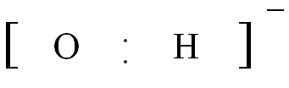 c. 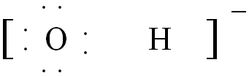 d. 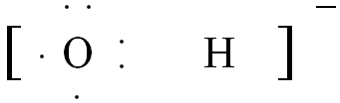

31. AsH3 32. H2Te 33. NH4⁺ 34. CO 35. NO₂⁻

31. Draw the Lewis structure for AsH3
ANSWER:
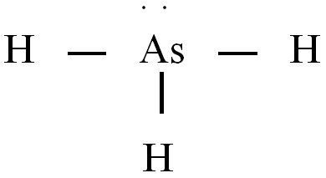

32. Draw the Lewis structure for the H2Te molecule.

ANSWER:
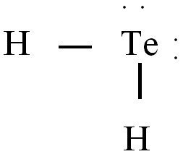

33. Draw the Lewis structure for NH4⁺

ANSWER:
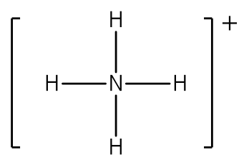

34. Lewis structure for CO

ANSWER:

35. Draw the lewis structure for NO₂⁻
ANSWER (either picture – there are resonance structures)

