**Direct current and alternating current and PoWer Notes**

Electricity can move around a circuit in two different ways. In the big picture up above, you can see electrons racing around a loop like race cars on a track, always going in the same direction. This type of electricity is called **direct current** (DC) and most toys and small gadgets have circuits that work this way.

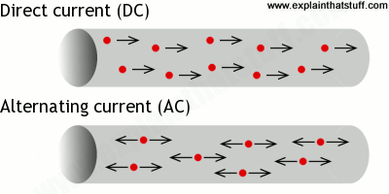

*Artwork: Top: In a direct current (DC) circuit, electrons always flow in the same direction. Bottom: In an alternating current (AC) circuit, the electrons reverse direction many times each second.*

The bigger appliances in your home use a different kind of electricity called **alternating current** (AC). Instead of always flowing the same way, the electrons constantly reverse direction—about 50–60 times every second (this is known as the frequency). Although you might think that makes it impossible for energy to be carried round a circuit, it doesn't! Take the flashlight bulb in the circuit above. With direct current, new electrons keep streaming through the filament (a thin piece of wire inside the bulb), making it heat up and give off light. With alternating current, the same old electrons whiz back and forth in the filament. You can think of them running on the spot, heating up the filament so it still makes bright light we can see. So both types of current can make the lamp work even though they flow in different ways. Most other electric appliances can also work using either direct or alternating current, though some circuits do need AC to be changed to DC (or vice versa) to work correctly.

**Current** is the amount of charge that flows past an ammeter every second of time.

* Current is measured in Amperes - A
* Charge is measured in Coulombs – C
* Time is measured in seconds – s

**Voltage** is the amount of energy that the charges (in the backpacks of the electrons) contain.

* Voltage is measured in Volts – V
* Energy is measured in Joules – J
* Charge is measured in Coulombs - C

**PoWer**

**What does a LB do? Think EasyBake Oven!!!**

|  |
| --- |
|  |
|  |
|  |
|  |

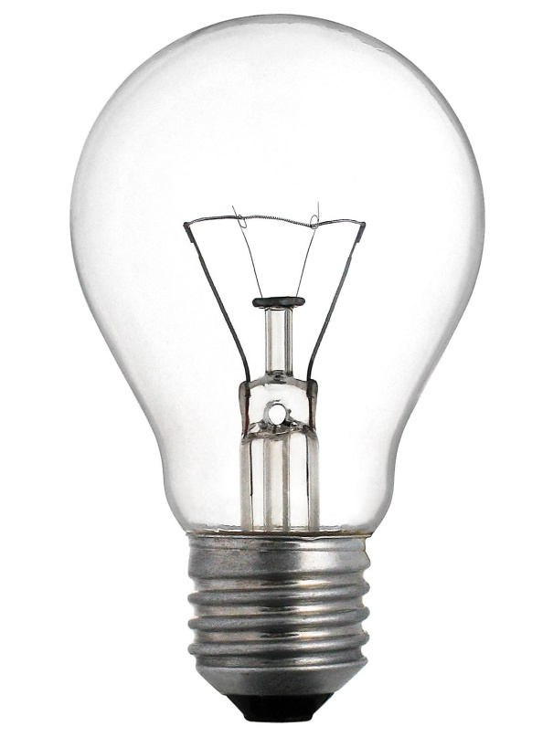

**What does a 100 W LB do compared to a 60 W LB?**

|  |
| --- |
|  |
|  |
|  |
|  |

**The rate at which energy is converted from one form to another is power.**

**Power is how fast energy is generated or used.**

**Power is how much energy is used in a given time period.**

**Do not confuse power and energy!!**

### Power is:

### 1)

### 2)

### Equations:

### How can PoWer exist as 2 very different equations?

### A 100 watt light burns just as brightly in both Europe and in Canada and uses the same amount of power in each case.

### In Europe it uses a higher voltage (220 V) and lower current; in North America, there's a lower voltage (120 V) and higher current.

Together, voltage and current give you electrical **power**. The bigger the voltage and the bigger the current, the more electrical power you have.

**Problems:** Show your work and include formulae, rearranged formulae and units. Because I said so and it is my class and I know what is best for you!!

**Units of Electricity:**

1

Which of the following correctly describes the units of Current and of Potential Difference?

|  |  |
| --- | --- |
| A) | 1 A = 1 C•s and 1 V = 1 J•C |
| B) | 1 A = 1 C/s and 1 V = 1 J/C |
| C) | 1 A = 1 C/s and 1 V = 1 J•C |
| D) | 1 A = 1 C•s and 1 V = 1 J/C |

2

Electrical potential difference is expressed in joules per coulomb (J/C) and electric current in coulombs per second (C/s). Using this information and knowing that 1 W = 1 J/1 s, which of the following units could apply to electrical energy?

A) V•A•s

B) W•s

C) J•s

D) kWh

E) W

F) VA

3

Which of the following is a unit of electrical energy?

|  |  |
| --- | --- |
| A) | V•A |
| B) | Ω•A2 |
| C) | W•s |
| D) | kW/h |

**E = Pt or P =**

1. A 750 Watt hairdryer is used for 15 minutes.

Calculate the amount of energy in Joules used by the hairdryer for this period of time.

Calculate the amount of energy in kWh used by the hairdryer for this period of time.

If Hydro QC charges your parents approx. 6.5 ¢ per kWh of electrical energy, how much does blow drying your hair cost?

2. A room has a 60 W, a 100 W and a 150 W LB.

How much would it cost to use all of the light bulbs for 2.5 h?

3. A microwave has a power rating of 1400 W. A convection oven has a power rating of 5000 W and takes 45 minutes to cook a baked potato.

At 6.5 ¢ per kWh how much does it cost to bake a potato in the convection oven?

A microwave oven takes 6 min to bake the same potato. How much?

4. How much does it cost to run a 615 W refrigerator for a year?

5. How long was a 15 W radio on for if it used 2.35 x 10 8 J of energy?

6. What is the power rating in kW of an appliance that runs for 4.5 s and uses 6.2 x 10 2 J of energy?

**P = IV**

1. What is the power when a voltage of 120 V drives a 2 A current through a device?

2. What is the current reading on an ammeter when a 60 W light bulb is connected to a 120 V source?

3. A bulb with a resistance of 330 Ω is plugged into a 240 V source in Paris. What is the current flowing through the bulb?

4. If part of an electric circuit dissipates energy at 6 W when it draws a current of 3 A, what voltage is impressed upon it?

5. An appliance runs for 5 h and uses 3.4 x 10 25 J of electrical energy. If it is connected to a conventional 120 V source, how much current does it use?

6. How much does it cost to run an appliance that is connected to a 120 V source and has a resistance of 500 Ω for 2 weeks?

7. What is the power rating of the LB in the following circuit if an ammeter reads 300 mA?

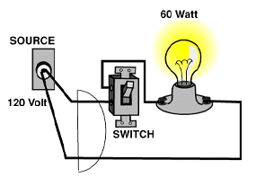

8

Three resistors are connected in parallel in the electrical circuit shown below. The value of resistance R is unknown.

The potential difference at the terminals of the battery is 24 V. The current furnished by the battery is 12 A.



How much power is used by the unknown resistor?

|  |  |
| --- | --- |
| A) | 27 W |
| B) | 36 W |
| C) | 108 W |
| D) | 144 W |

9

The following graph shows the variation of the voltage across the terminals of a ceramic element as a function of the intensity of the current passing through it.



What power is dissipated when this ceramic element is connected to a voltage of 5.0 V?

|  |  |
| --- | --- |
| A) | 20 W |
| B) | 10.0 W |
| C) | 5.0 W |
| D) | 2.5 W |