4 Step ∆H neutralization for an Acid or a Base
The following situations are exothermic:
- Acid dissolving in water
- Base dissolving in water
- Acid and Base reacting
- Fermentation
- Composting
- Digestion
- Combustion

When an acid reacts with a base heat energy is _____________________________________

Using a coffee cup calorimeter, 100.0 mL of a 0.50 M sodium hydroxide solution was added to
neutralize 50.0 mL of a 0.50 M sulfuric acid solution.

The following temperatures were recorded: Ti = 21.5 ºC and Tf = 26.0 ºC
The BCE for this neutralization reaction is:

___________________________________________________________________________

What is the molar heat of neutralization for NaOH?

Sketch!

Calculate ∆H for NaOH: You will be asked for either the Acid or the Base only!!!!!!!!

Problem
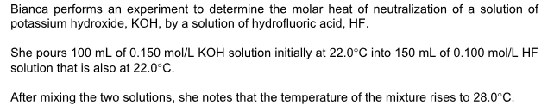

What is the heat of neutralization for the acid in the above reaction?

