3 Ways to Classify Acids and Bases
http://www.chemguide.co.uk/physical/acidbaseeqia/theories.html

Please remember that whenever there is water present the following equilibrium exists:

___________________________________________________________________________

Arrhenius Acid
- a substance that dissociates in water to form hydrogen ions (H ⁺)
e.g.

Arrhenius Base
- a substance that dissociates in water to form hydroxide (OH ⁻) ions

- increases the concentration of OH ⁻ ions in an aqueous solution

e.g.

Bronsted-Lowry Acid

- a proton (hydrogen ion) donor

Bohr Diagram of a Hydrogen Atom:

Reaction between Water and HCl:

Bronsted-Lowry Base

- a proton (hydrogen ion) acceptor

Reaction between Water and Ammonia:

Lewis Acid

- a species that accepts an electron pair

e.g. carbon dioxide dissolving in water to form carbonic acid

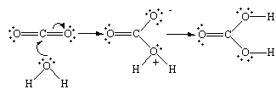

Lewis Base

- a species that donates an electron pair

Water is amphoteric -- it can go both ways -- it can act as an acid or a base!

